**DAY – 1**

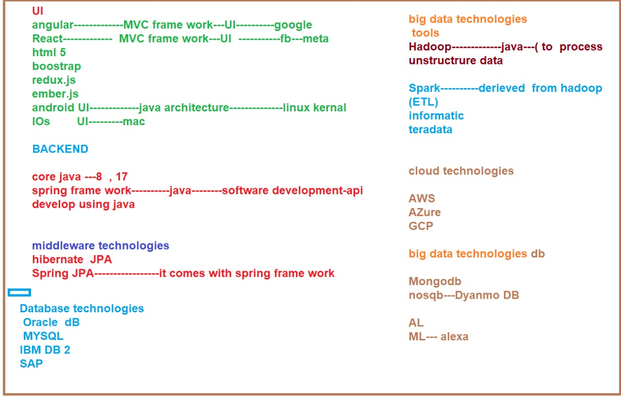

* <https://www.w3schools.com/js/js_json_intro.asp>

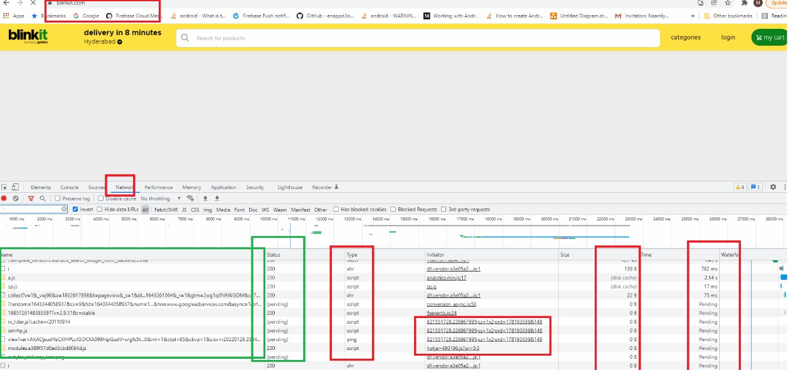

JAVA DOWNLOADING Link:

* <https://www.oracle.com/in/java/technologies/javase/javase8u211-later-archive-downloads.html>

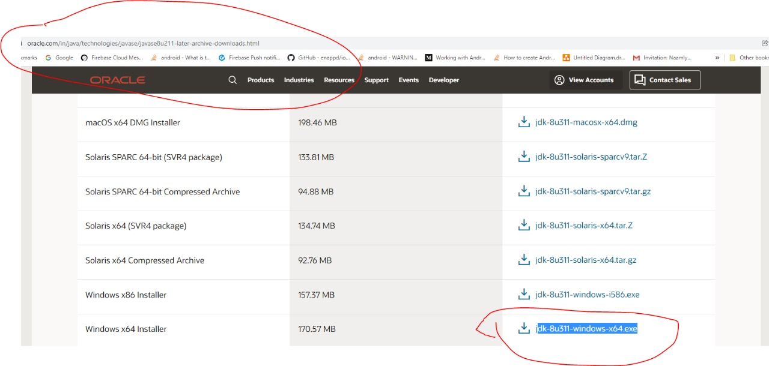

API SPECIFICATIONS FOR JAVA:

* https://docs.oracle.com/javase/8/docs/api/

GIT HUB Reference Link:

* <https://github.com/checkcc/capegemine2022.git>

Git hub Uploading Steps:

1 .git clone <https://github.com/checkcc/capegemine2022.git>

2. git add .

3. git status

4.git commit -m "my day1 java prgs"

5. git push origin main or master

**DAY – 2**

OPERATORS :

* <https://www.slideshare.net/Thenmurugeshwari/operators-in-java>

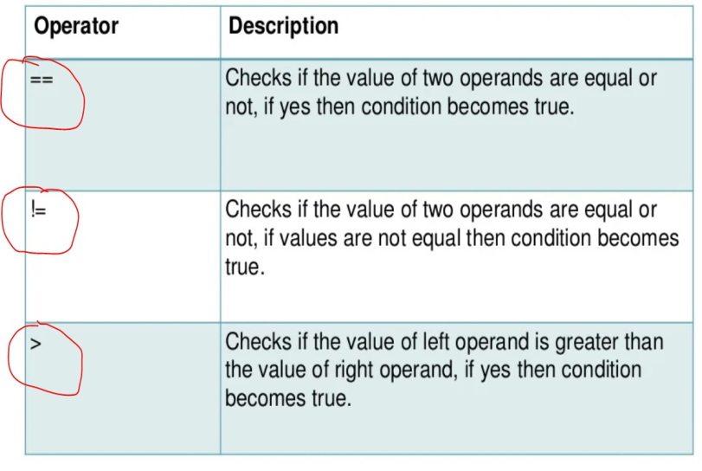

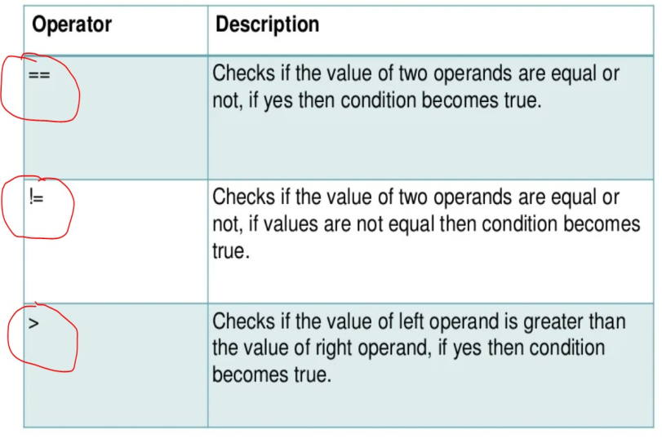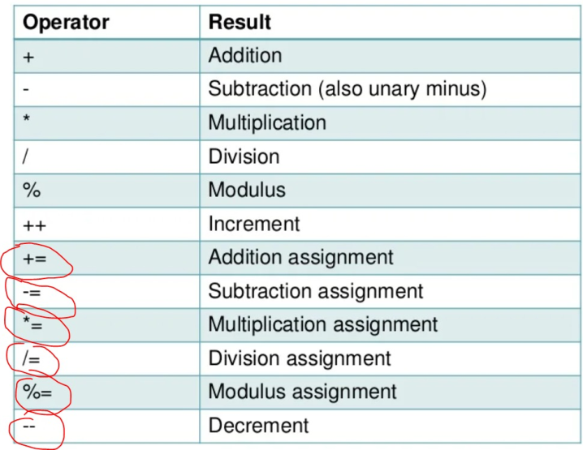

ACCESS SPECIFIERS IN JAVA:

* <https://www.slideshare.net/HrithikShinde/access-specifiersmodifiers-in-java>

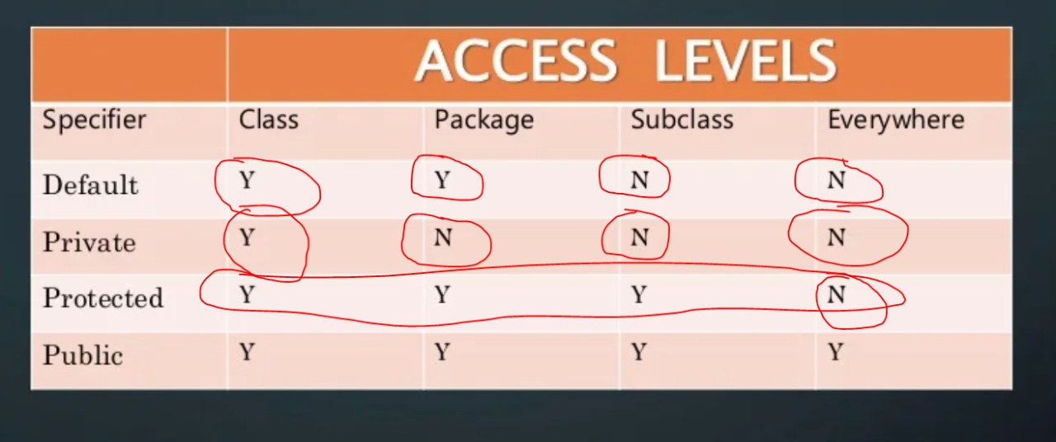

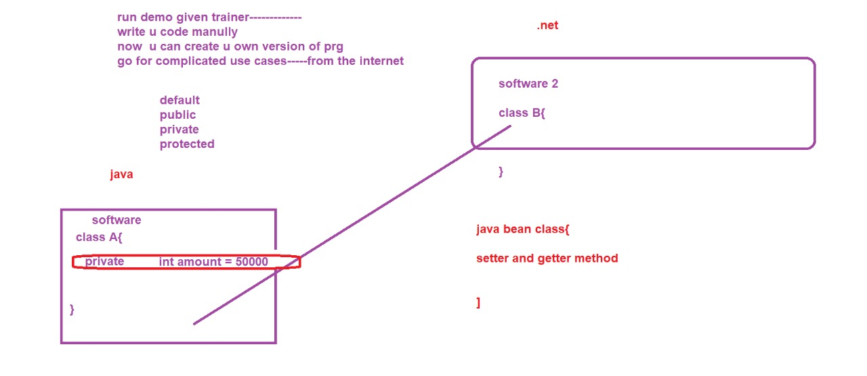

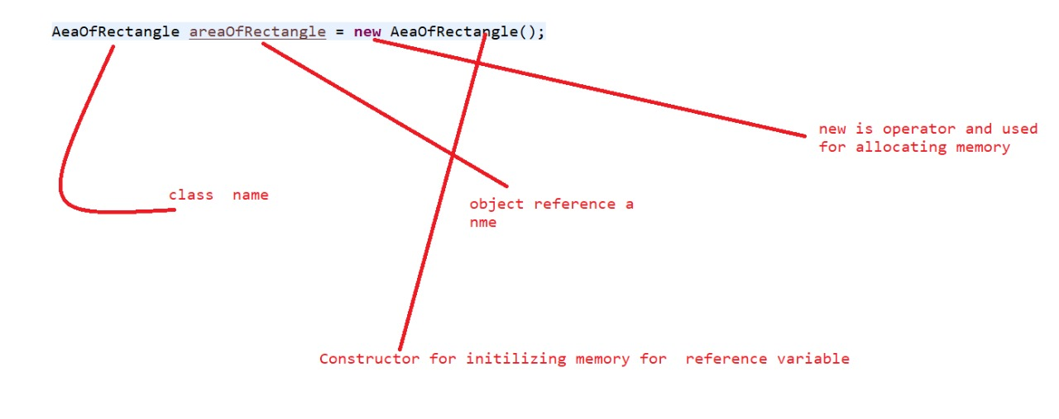

List Of YouTube References:

* Git: <https://www.youtube.com/watch?time_continue=1&v=HVsySz-h9r4&feature=emb_logo>
* Java Tutorials: <https://docs.oracle.com/javase/tutorial/index.html>
* JVM: <https://www.youtube.com/watch?time_continue=2&v=ZBJ0u9MaKtM&feature=emb_logo>
* First Java Program : <https://www.youtube.com/watch?v=qQdfyb2KRko&feature=emb_logo>
* Data Types: <https://www.youtube.com/watch?v=bqPIWlnjWbA&feature=emb_logo>
* IF ELSE: <https://www.youtube.com/watch?v=6Ocu3IHuBCk>
* LOOPS : <https://www.youtube.com/watch?v=6djggrlkHY8&feature=emb_logo>
* Switch Statements: <https://www.youtube.com/watch?v=RVRPmeccFT0>
* Operators : <https://www.youtube.com/watch?v=Pa0lUMWmmm0>
* Array:https://www.youtube.com/watch?v=_NfwcH5zKpA&feature=emb_logo
* https://www.youtube.com/watch?v=L06uGnF4IpY
* OOPS: https://www.youtube.com/watch?v=-HafzawNlUo
* Classes and Objects : https://www.youtube.com/watch?v=V-PQvKUtSY8
* Constructor: https://www.youtube.com/watch?v=YqBVgUh64Ks
* Modifiers :https://www.youtube.com/watch?time_continue=9&v=Ruy-yzj-JG8&feature=emb_logo
* Packages :https://www.youtube.com/watch?v=eEujVn-ZTLE&feature=emb_logo
* Encapsulation :https://www.youtube.com/watch?v=4VBdNbWeTZw&feature=emb_logo
* Abstract Classes: https://www.youtube.com/watch?v=RcIsb9iFKH8&feature=emb_logo
* Inheritance :https://www.youtube.com/watch?v=_9R_in_7cT4
* Polymorphism :https://www.youtube.com/watch?v=0xw06loTm1k&feature=emb_logo
* Arrays:https://www.youtube.com/watch?v=_NfwcH5zKpA&feature=emb_logo Arrays
* Strings:https://www.youtube.com/watch?time_continue=1&v=r3DBIDyzLUI&feature=emb_logo
* StringBuilder, StringBuffer: https://www.youtube.com/watch?v=7WsU9SyS-uI&feature=emb_logo
* Static :https://www.youtube.com/watch?v=qRCEdWQ0f4Q
* Non static and Static :https://www.youtube.com/watch?v=msXJVIecGp0
* Anonymous Object: https://www.youtube.com/watch?v=AmRjm4Cksmo
* Interface :https://www.youtube.com/watch?v=Ggjxn8Q9VuE
* Wrapper Classes :https://www.youtube.com/watch?v=XKEBjp1k8cQ
* Boxing and UnBoxing :https://www.youtube.com/watch?v=O6IkXdRVp6I
* Exception Handling: https://www.youtube.com/watch?v=8WTVLa1Xtsk&list=PLsyeobzWxl7rS9B2K1l--VDpCn41gijnV
* Collections:https://www.youtube.com/watch?v=5NOLuoG6fcQ&list=PLsyeobzWxl7oJj5BXYF088REBm-K4c_SR
* https://www.youtube.com/watch?v=XUTJZZDZG8k&list=PLzS3AYzXBoj8XCaW6-o73-FkvZPMas41L
* https://www.youtube.com/watch?v=mQ9uxTWZCXA&list=PLFGoYjJG_fqooGAq7UKpkXb8l4xjyEQUr
* https://www.youtube.com/watch?v=0xrhqxTOphI
* https://www.youtube.com/watch?v=W5gnVp1NUNU
* IO and File Handling :https://www.youtube.com/watch?v=kD_HqZP8MLY
* https://www.youtube.com/watch?v=QfGVi89AV4c
* https://www.youtube.com/watch?v=OUnDCLhkh_E&list=PLcJ7Ar5qZeeH01O-Pe7aHLQ9UXEp47_Lw
* https://www.youtube.com/watch?v=3YRahx2ltSg
* https://www.youtube.com/watch?v=waXvGUEjTTs
* JDBC : https://www.youtube.com/watch?v=y_YxwyYRJek&list=PLsyeobzWxl7rU7Jz3zDRpqB-EODzBbHOI
* https://www.youtube.com/watch?v=8-iQDUl10vM&list=PLEAQNNR8IlB4R7NfqBY1frapYo97L6fOQ
* https://www.youtube.com/watch?v=BOUMR85B-V0&list=PLhs1urmduZ2-yp3zID5rMEmXDETN8xvMo
* Java 8 new features :https://www.youtube.com/watch?v=grEKMHGYyns
* https://www.youtube.com/watch?v=gpIUfj3KaOc&list=PLqq-6Pq4lTTa9YGfyhyW2CqdtW9RtY-I3
* https://www.youtube.com/watch?v=a8jvxBbswp4&list=PLqq-6Pq4lTTa9YGfyhyW2CqdtW9RtY-I3&index=10
* https://www.youtube.com/watch?v=QRwG9X9l6xI&list=PLsyeobzWxl7qbvNnJKjYbkTLn2w3eRy1Q
* <https://www.youtube.com/watch?v=4e_RsZWdiSc>

INHERITANCE :

* <https://www.javatpoint.com/inheritance-in-java>

**DAY – 3**

INHERITANCE :

Terms used in Inheritance

Class: A class is a group of objects which have common properties. It is a template or blueprint from which objects are created.

Sub Class/Child Class: Subclass is a class which inherits the other class. It is also called a derived class, extended class, or child class.

Super Class/Parent Class: Superclass is the class from where a subclass inherits the features. It is also called a base class or a parent class.

Reusability: As the name specifies, reusability is a mechanism which facilitates you to reuse the fields and methods of the existing class when you create a new class. You can use the same fields and methods already defined in the previous class.

Inheritance represents the IS-A relationship which is also known as a parent-child relationship.

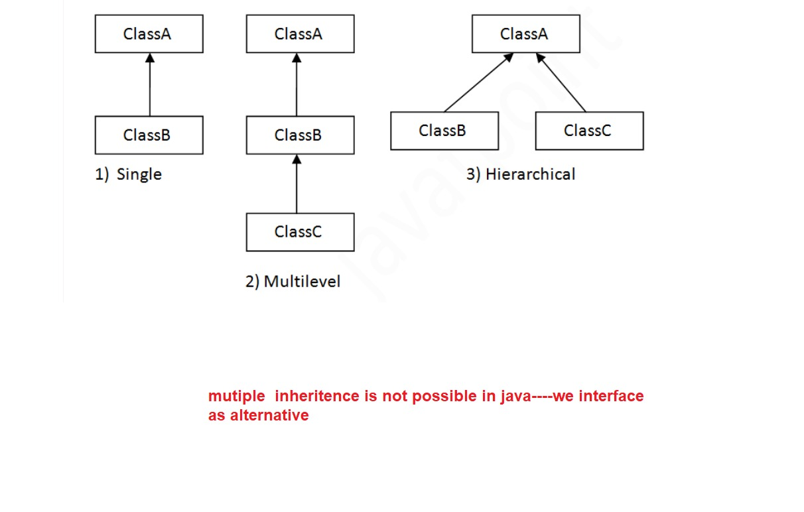

* <https://www.geeksforgeeks.org/what-is-has-a-relation-in-java/>

Association is the relation between two separate classes which establishes through their Objects.

Composition and Aggregation are the two forms of association. In Java,

a Has-A relationship is otherwise called composition. It is additionally utilized for code reusability in Java. In Java, a Has-A relationship essentially implies that an example of one class has a reference to an occasion of another class or another occurrence of a similar class.

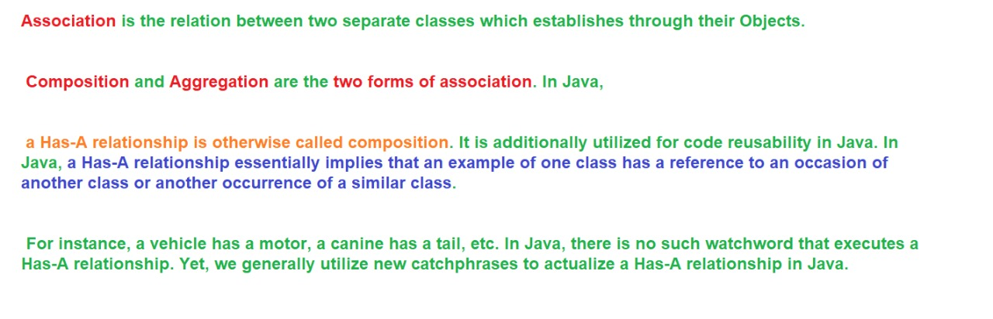

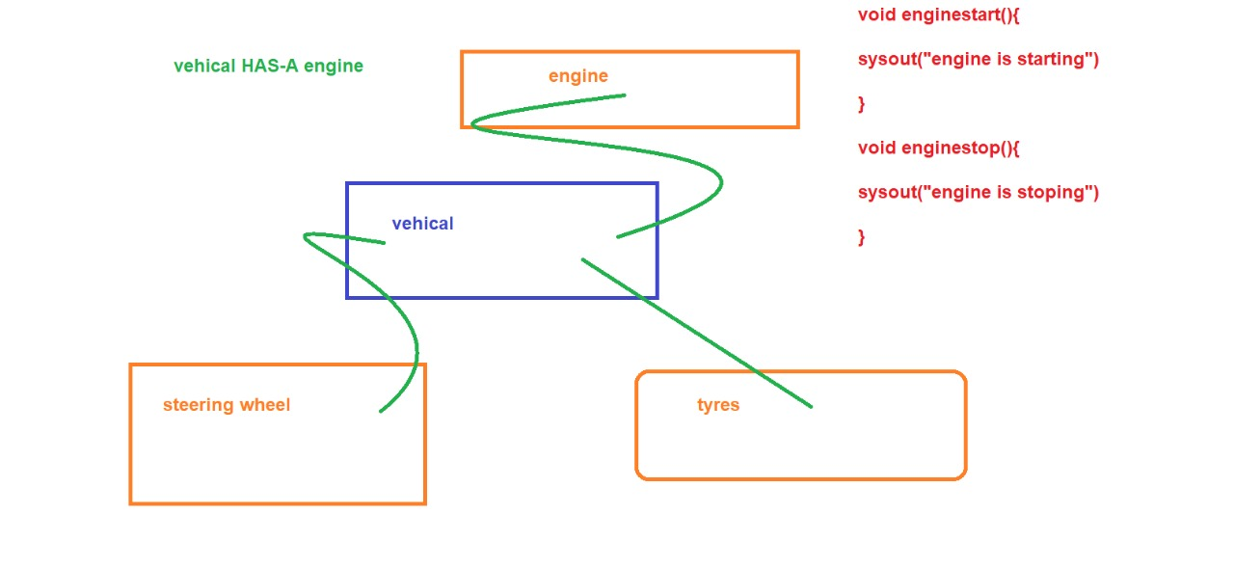

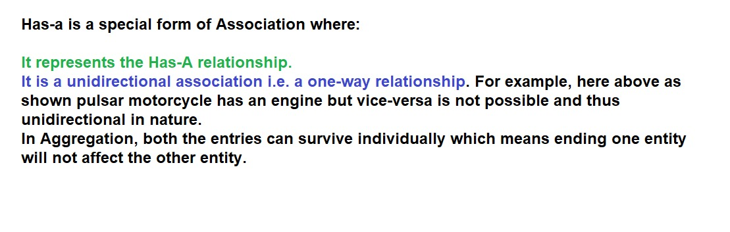

* <https://www.geeksforgeeks.org/what-is-has-a-relation-in-java/>

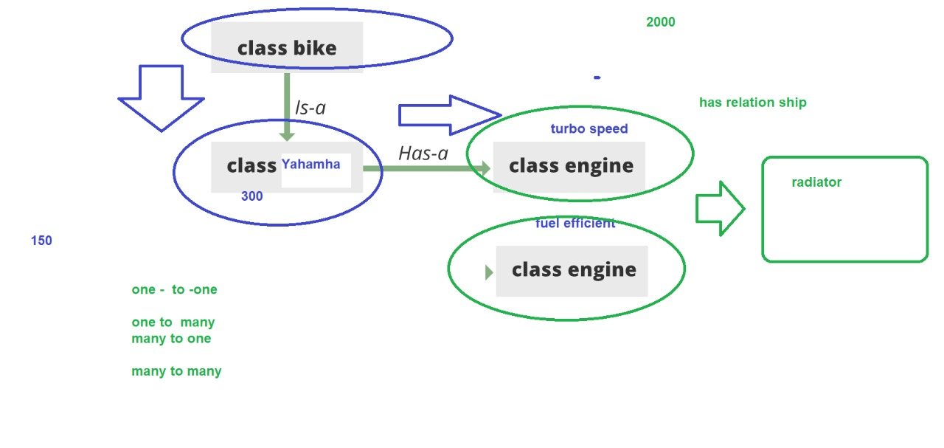

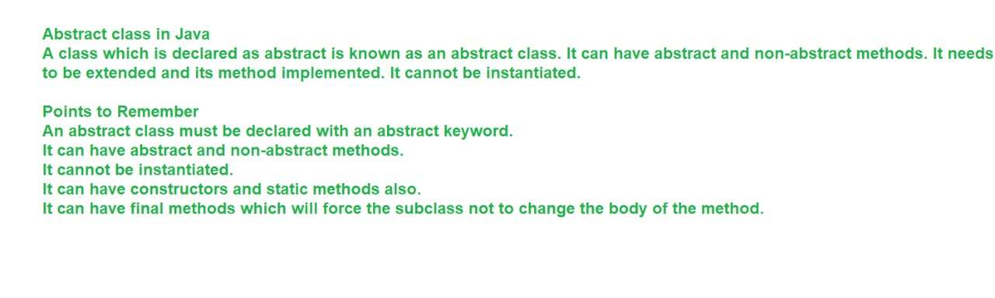

diamond shape problem:

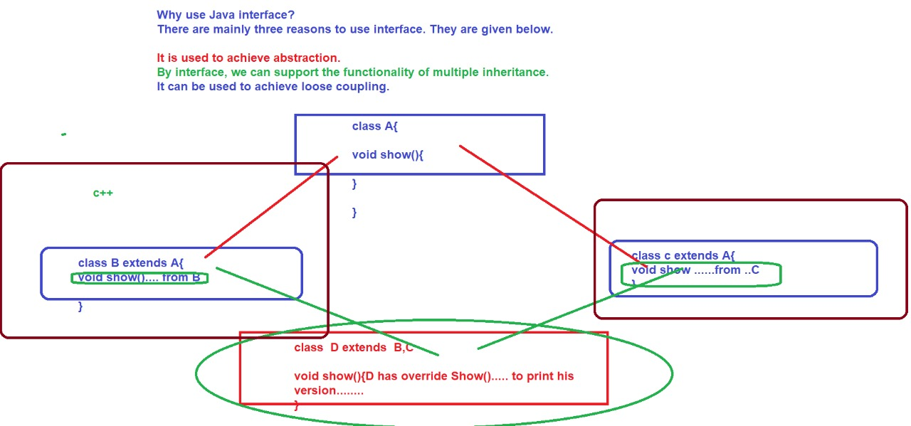

* <https://www.slideshare.net/HarisBinZahid/abstract-class-and-interface-49451395>
* <https://www.w3schools.com/java/java_interface.asp>
* https://www.javatpoint.com/interface-in-java#:~:text=An%20interface%20in%20Java%20is,static%20constants%20and%20abstract%20methods.&text=There%20can%20be%20only%20abstract,and%20multiple%20inheritance%20in%20Java.

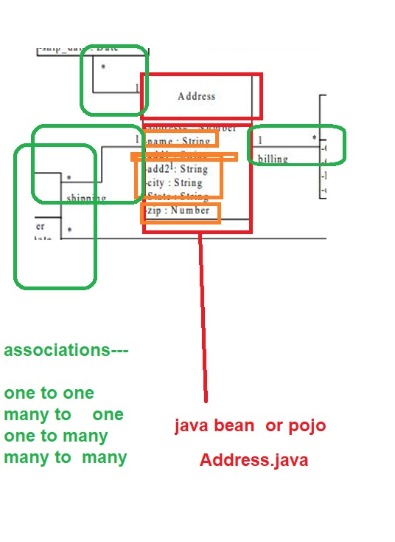

**DAY – 4**

INTERFACES :

* [Interface in Java - Javatpoint](https://www.javatpoint.com/interface-in-java#:~:text=An%20interface%20in%20Java%20is,static%20constants%20and%20abstract%20methods.&text=There%20can%20be%20only%20abstract,and%20multiple%20inheritance%20in%20Java)

An interface is different from a class in several ways, including −

You cannot instantiate an interface.

An interface does not contain any constructors.

All of the methods in an interface are abstract.

An interface cannot contain instance fields.

The only fields that can appear in an interface must be declared both static and final.

An interface is not extended by a class; it is implemented by a class.

An interface can extend multiple interfaces.

EXCEPTION HANDLING:

* <https://www.javatpoint.com/exception-handling-in-java>

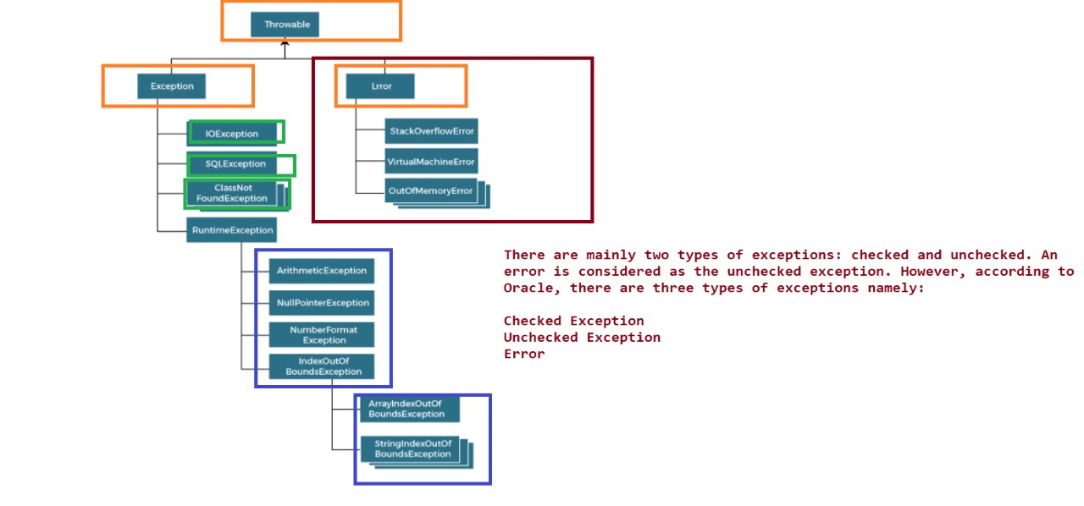

ArithmeticException

It is thrown when an exceptional condition has occurred in an arithmetic operation.

ArrayIndexOutOfBoundsException

It is thrown to indicate that an array has been accessed with an illegal index. The index is either negative or greater than or equal to the size of the array.

ClassNotFoundException

This Exception is raised when we try to access a class whose definition is not found

FileNotFoundException

This Exception is raised when a file is not accessible or does not open.

IOException

It is thrown when an input-output operation failed or interrupted

InterruptedException

It is thrown when a thread is waiting, sleeping, or doing some processing, and it is interrupted.

NoSuchFieldException

It is thrown when a class does not contain the field (or variable) specified

NoSuchMethodException

It is thrown when accessing a method which is not found.

NullPointerException

This exception is raised when referring to the members of a null object. Null represents nothing

NumberFormatException

This exception is raised when a method could not convert a string into a numeric format.

RuntimeException

This represents any exception which occurs during runtime.

StringIndexOutOfBoundsException

It is thrown by String class methods to indicate that an index is either negative or greater than the size of the string

List Of Exceptions :

* <https://www.geeksforgeeks.org/types-of-exception-in-java-with-examples/>

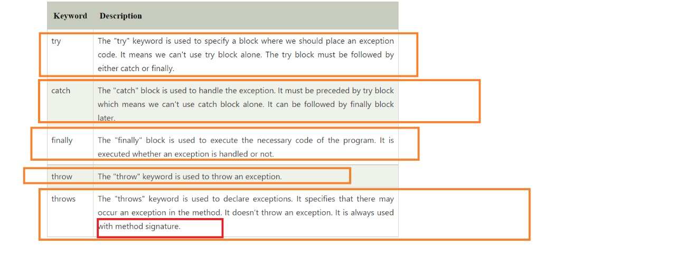

* <https://www.geeksforgeeks.org/g-fact-32-user-defined-custom-exception-in-java/>

**DAY – 5**

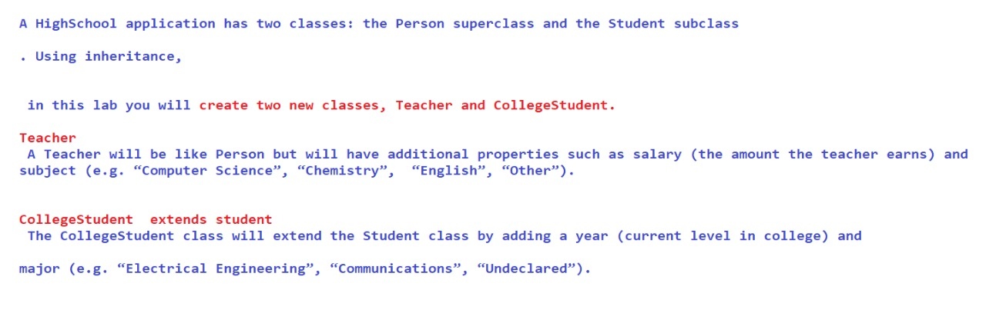

* <https://docs.oracle.com/javase/8/docs/api/java/lang/String.html>
* <https://www.journaldev.com/797/what-is-java-string-pool>

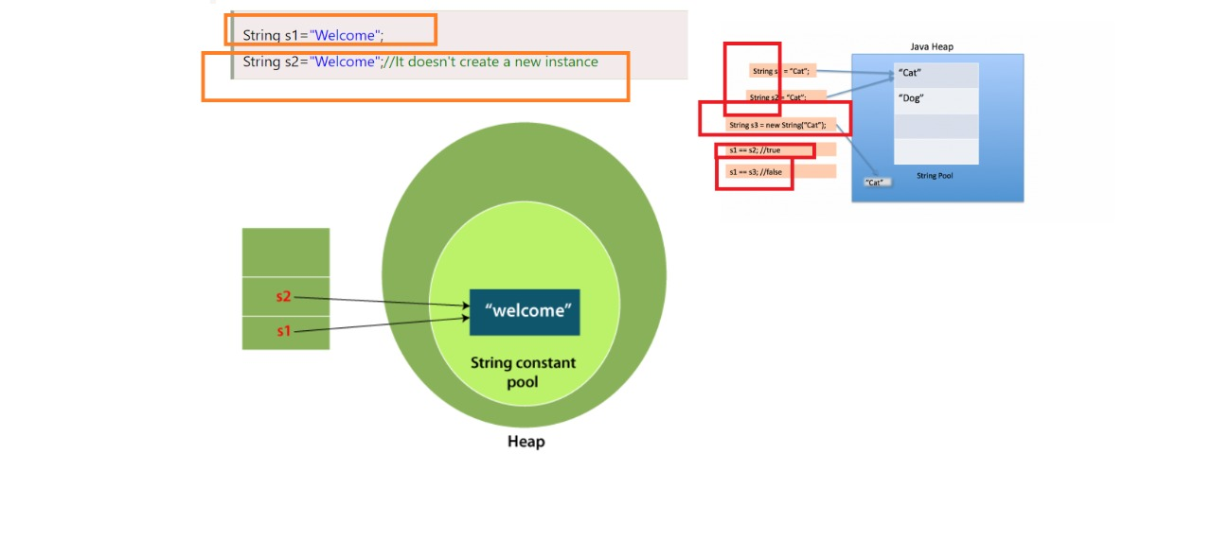

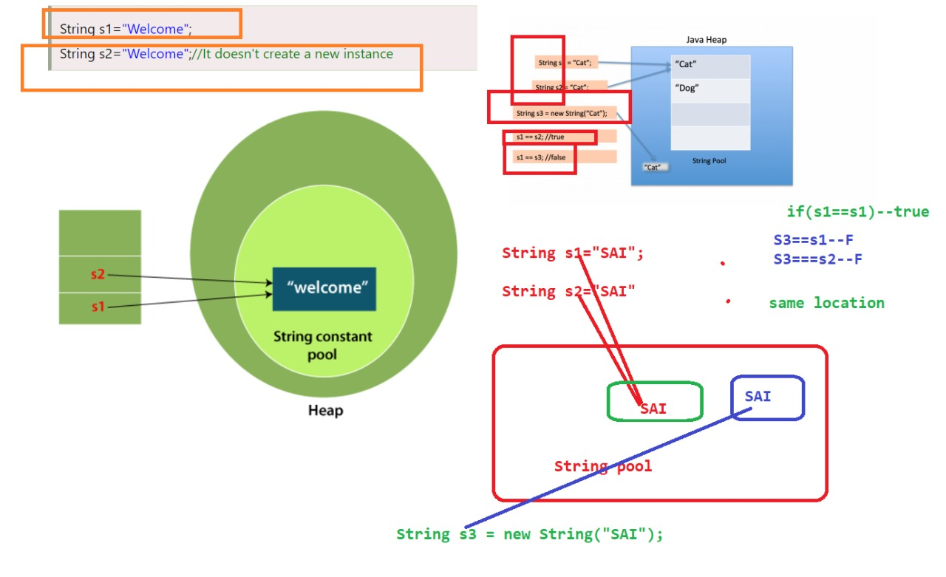

**DAY – 6**

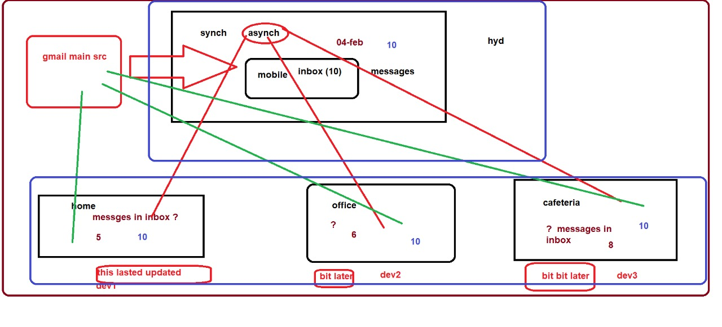

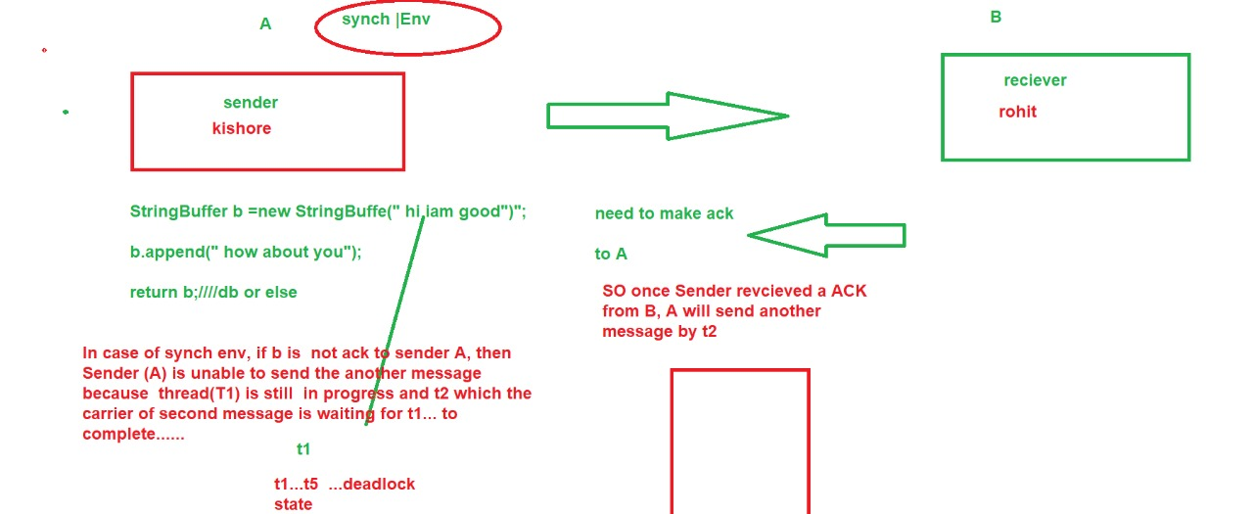

* <https://www.baeldung.com/java-wrapper-classes>
* <https://www.slideshare.net/tuhinkundu007/threads-in-java-45202167>

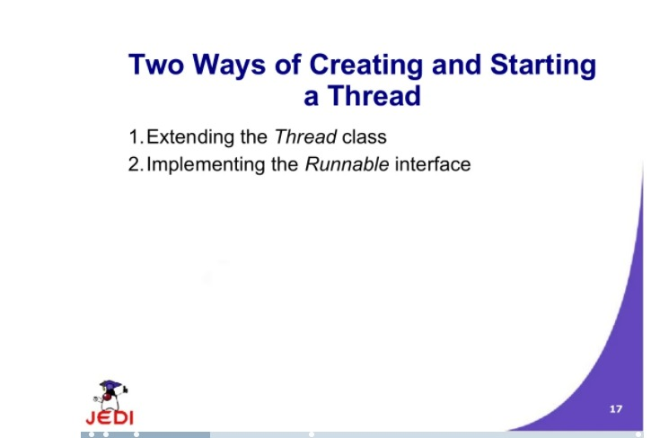

* <https://www.slideshare.net/babu4b4u/javathread>

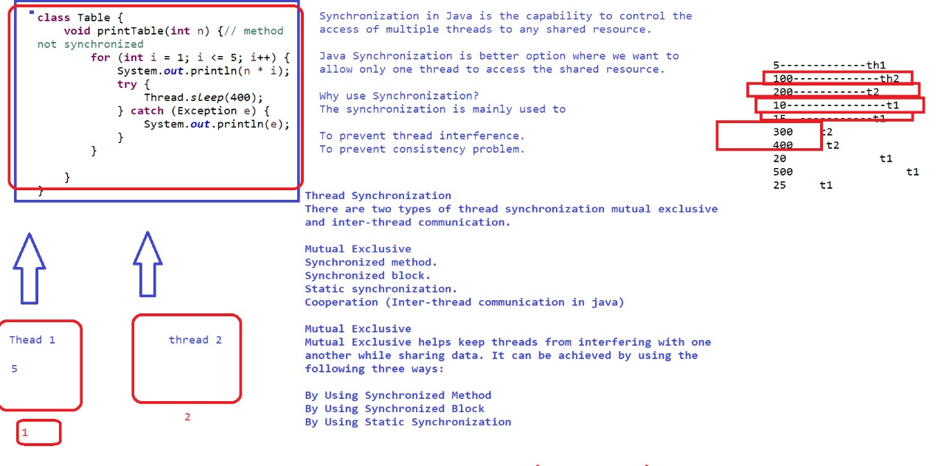

**concurrent package**

**BlockingDeque<E>**

A Deque that additionally supports blocking operations that wait for the deque to become non-empty when retrieving an element, and wait for space to become available in the deque when storing an element.

**BlockingQueue<E>**

A Queue that additionally supports operations that wait for the queue to become non-empty when retrieving an element, and wait for space to become available in the queue when storing an element.

**Callable<V>**

A task that returns a result and may throw an exception.

**CompletableFuture.AsynchronousCompletionTask**

A marker interface identifying asynchronous tasks produced by async methods.

**CompletionService<V>**

A service that decouples the production of new asynchronous tasks from the consumption of the results of completed tasks.

**CompletionStage<T>**

A stage of a possibly asynchronous computation, that performs an action or computes a value when another CompletionStage completes.

**ConcurrentMap<K,V>**

A Map providing thread safety and atomicity guarantees.

**ConcurrentNavigableMap<K,V>**

A ConcurrentMap supporting NavigableMap operations, and recursively so for its navigable sub-maps.

**Delayed**

A mix-in style interface for marking objects that should be acted upon after a given delay.

**Executor**

An object that executes submitted Runnable tasks.

**ExecutorService**

An Executor that provides methods to manage termination and methods that can produce a Future for tracking progress of one or more asynchronous tasks.

**ForkJoinPool.ForkJoinWorkerThreadFactory**

Factory for creating new ForkJoinWorkerThreads.

**ForkJoinPool.ManagedBlocker**

Interface for extending managed parallelism for tasks running in ForkJoinPools.

**Future<V>**

A Future represents the result of an asynchronous computation.

**RejectedExecutionHandler**

A handler for tasks that cannot be executed by a ThreadPoolExecutor.

**RunnableFuture<V>**

A Future that is Runnable.

**RunnableScheduledFuture<V>**

A ScheduledFuture that is Runnable.

**ScheduledExecutorService**

An ExecutorService that can schedule commands to run after a given delay, or to execute periodically.

**ScheduledFuture<V>**

A delayed result-bearing action that can be cancelled.

**ThreadFactory**

An object that creates new threads on demand.

**TransferQueue<E>**

A BlockingQueue in which producers may wait for consumers to receive elements.

<https://www.javatpoint.com/java-deque-arraydeque>

**IO INTERFACE**

**Closeable**

A Closeable is a source or destination of data that can be closed.

**DataInput**

The DataInput interface provides for reading bytes from a binary stream and reconstructing from them data in any of the Java primitive types.

**DataOutput**

The DataOutput interface provides for converting data from any of the Java primitive types to a series of bytes and writing these bytes to a binary stream.

**Externalizable**

Only the identity of the class of an Externalizable instance is written in the serialization stream and it is the responsibility of the class to save and restore the contents of its instances.

**FileFilter**

A filter for abstract pathnames.

**FilenameFilter**

Instances of classes that implement this interface are used to filter filenames.

**Flushable**

A Flushable is a destination of data that can be flushed.

**ObjectInput**

ObjectInput extends the DataInput interface to include the reading of objects.

**ObjectInputValidation**

Callback interface to allow validation of objects within a graph.

**ObjectOutput**

ObjectOutput extends the DataOutput interface to include writing of objects.

**ObjectStreamConstants**

Constants written into the Object Serialization Stream.

**Serializable**

Serializability of a class is enabled by the class implementing the java.io.Serializable interface.

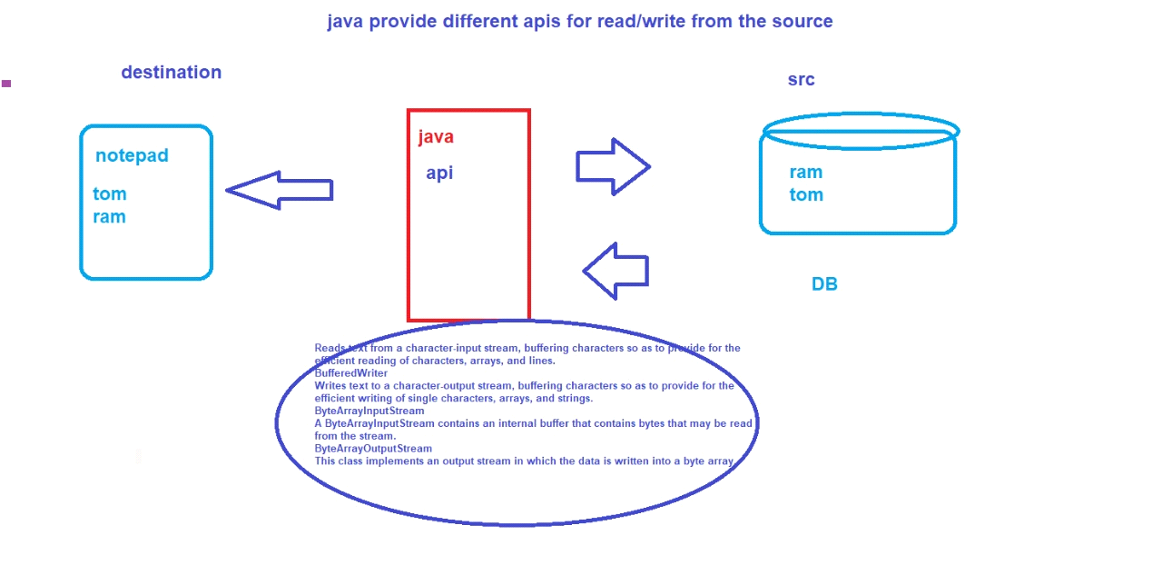

package com.demo.io;

import java.io.FileReader;

import java.io.IOException;

public class FileReaderDemo {

public static void main(String[] args) throws IOException {

FileReader ioreader = new FileReader("abc.txt");//mention the source for reading

int i;

while ((i = ioreader.read()) != -1) {

System.out.println((char) i);

}

ioreader.close(); // close io connection usig close() api

}

}

_________________________________________________________

package com.demo.io;

import java.io.FileInputStream;

import java.io.FileOutputStream;

import java.io.FileReader;

import java.io.IOException;

import java.io.InputStream;

import java.io.InputStreamReader;

import java.io.Reader;

/* *

*

* An InputStreamReader is a bridge from byte streams to character streams:

* It reads bytes and decodes them into characters using a specified charset.

* The charset that it uses may be specified by name or may be given explicitly,

* or the platform's default charset may be accepted.

*

*/

public class InputOutputStreamsDemo {

public static void main(String[] args) throws IOException {

InputStream in = new FileInputStream("abc.txt");

FileOutputStream out = new FileOutputStream("output_abx_rohit.txt");

int i;

while ((i = in.read()) != -1) {

out.write(i);

}

in.close();

System.out.println("done..");

}

}

________________________________________________________________________

InputStreams contains only read() related methods

OutputStreams contains only Write() related methods

-------------------------------------------------------------------------------------------------------------------

<https://www.programiz.com/java-programming/fileoutputstream>

**BufferedInputStream**

A BufferedInputStream adds functionality to another input stream-namely, the ability to buffer the input and to support the mark and reset methods.

**BufferedOutputStream**

The class implements a buffered output stream.

**BufferedReader**

Reads text from a character-input stream, buffering characters so as to provide for the efficient reading of characters, arrays, and lines.

**FileReader**

Convenience class for reading character files.

**FileWriter**

Convenience class for writing character files.

**FilterInputStream**

A FilterInputStream contains some other input stream, which it uses as its basic source of data, possibly transforming the data along the way or providing additional functionality.

FilterOutputStream

<https://docs.oracle.com/javase/7/docs/api/java/io/Serializable.html>

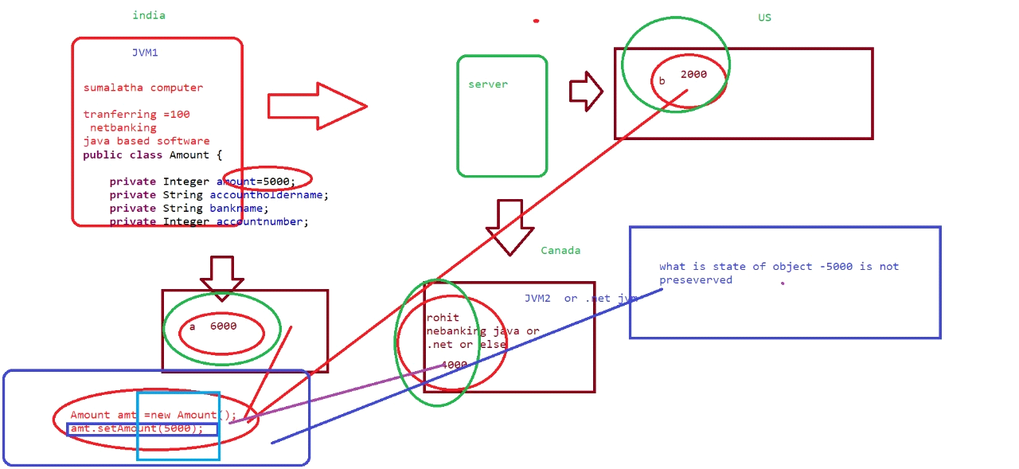

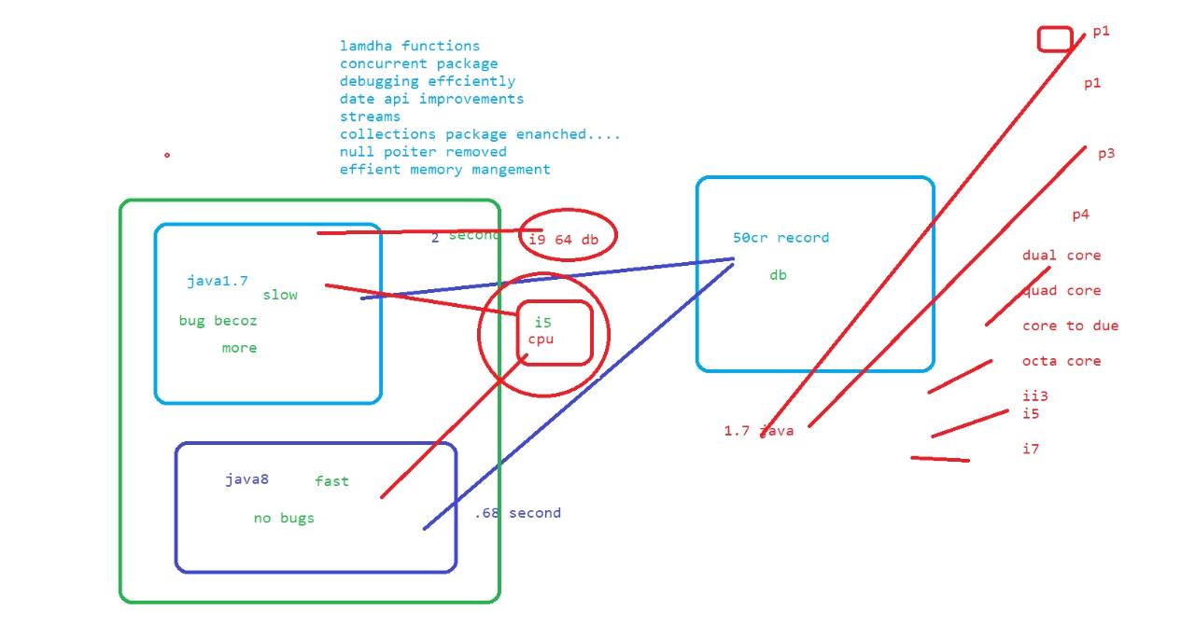

**LAMBDA EXPRESSION**

**parameter -> expression body**

Lambda expression facilitates functional programming, and simplifies the development a lot.

-------------------------------------------------------------------------------------------------------------------

package com.demo.java8.lamdhademo;

/*

* Following are the important characteristics of a lambda expression.

Optional type declaration − No need to declare the type of a parameter. The compiler can inference the same from the value of the parameter.

Optional parenthesis around parameter − No need to declare a single parameter in parenthesis.

For multiple parameters, parentheses are required.

Optional curly braces − No need to use curly braces in expression body if the body contains a single statement.

Optional return keyword − The compiler automatically returns the value if the body has a single expression to return the value.

Curly braces are required to indicate that expression returns a value.

*

* *

*/

@FunctionalInterface

interface Addable {

int add(int a, int ab);

}

public class LambdaExpressionWithAndWithoutReturnTypeDemo {

public static void main(String ar[]) {

Addable adddemo = (a,b)->(a+b); //no return type

System.out.println(adddemo.add(5, 5));

}

-------------------------------------------------------------------------------------------------------------------

package com.demo.java8.lamdhademo;

@FunctionalInterface

interface Sayable{

public String say();

}

public class WithNoParameter {

public static void main(String ar[]) {

//functional style

Sayable s =() ->{

return "hi how are you";

};

System.out.println(s.say());

}

}

**_________________________________________________________**

<https://www.w3schools.com/java/java_lambda.asp>

<https://docs.oracle.com/javase/8/docs/api/java/util/function/BiFunction.html>

<https://docs.oracle.com/javase/8/docs/api/java/util/function/Supplier.html>

<https://docs.oracle.com/javase/8/docs/api/java/util/function/Consumer.html>

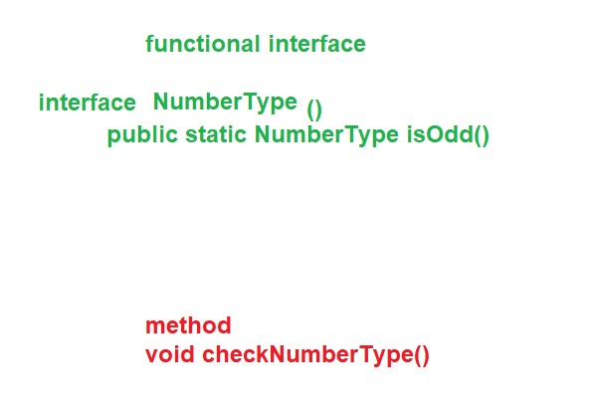

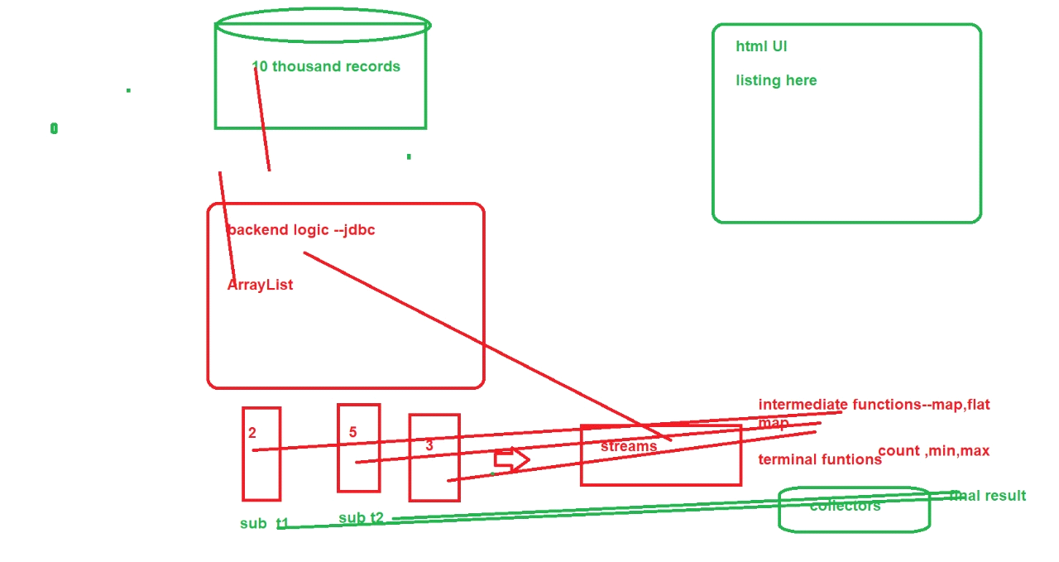

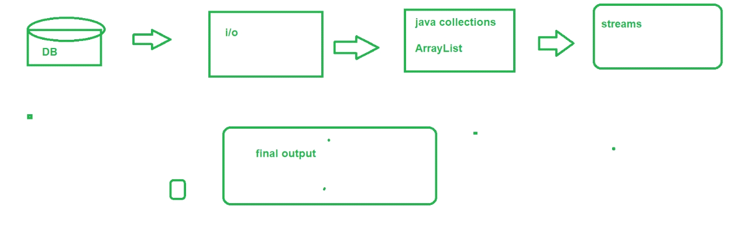

**STREAMS**

<https://www.slideshare.net/VenkataNagaRavi/java-8-lambda-and-streams>

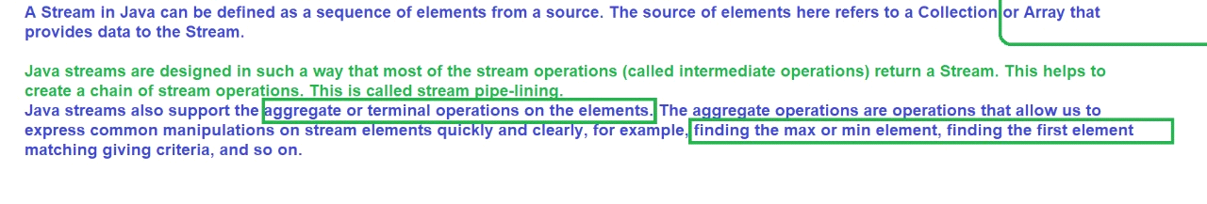

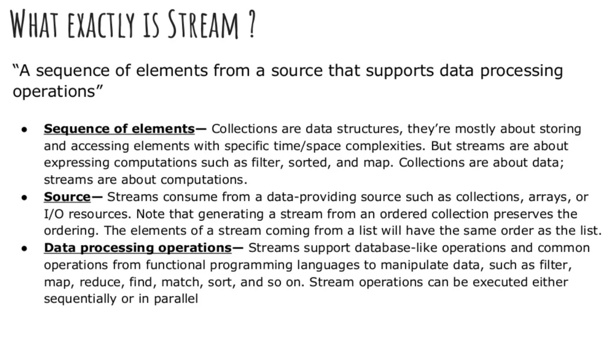

<https://www.slideshare.net/NexThoughts/java-8-features-79916896>

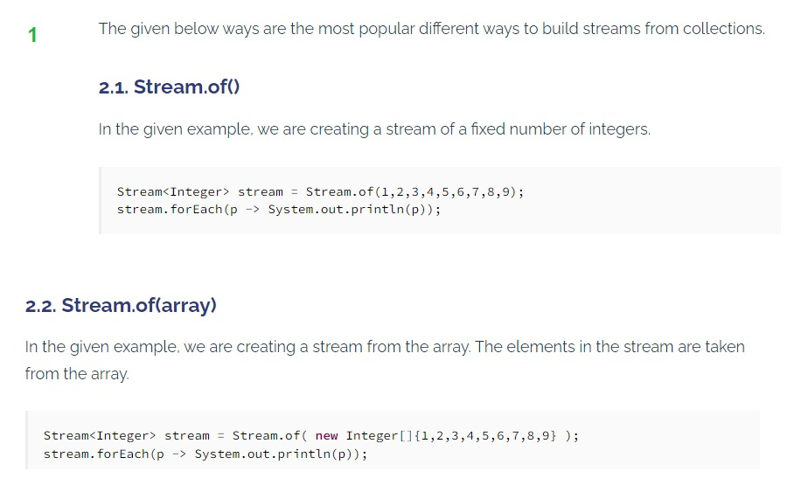

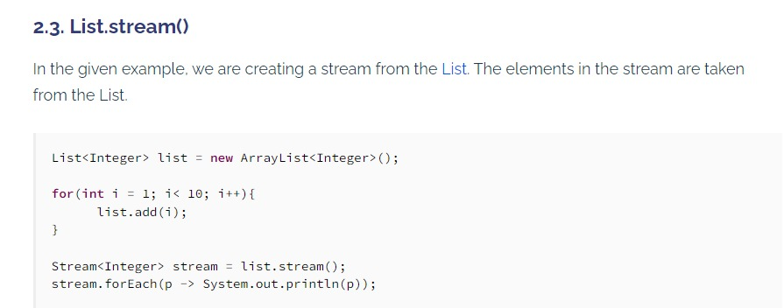

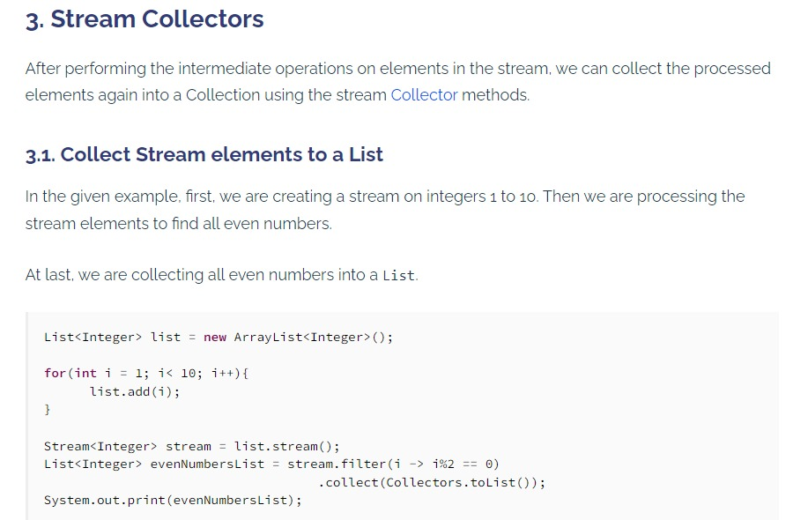

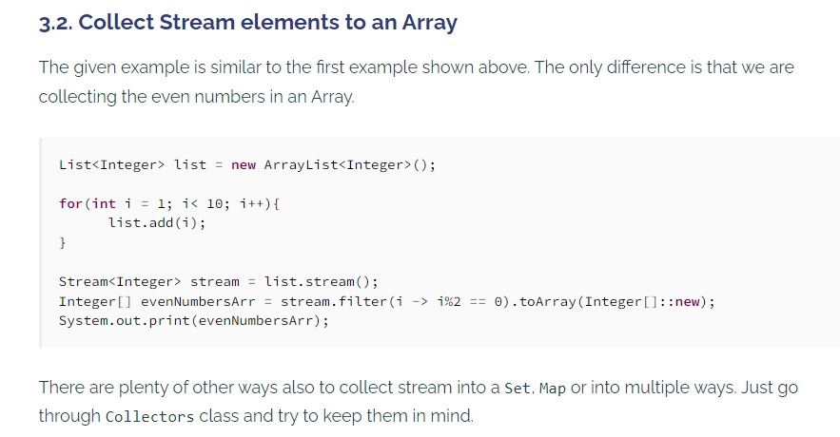

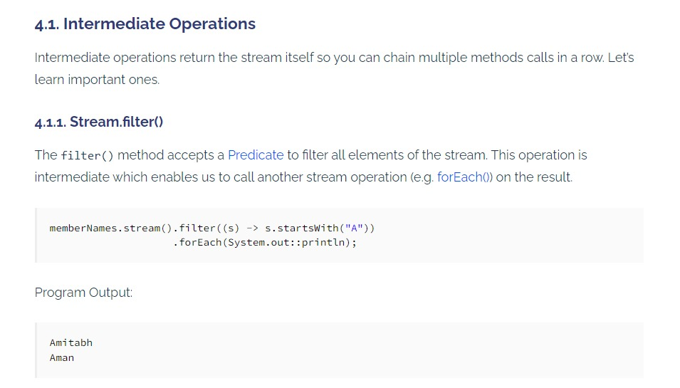

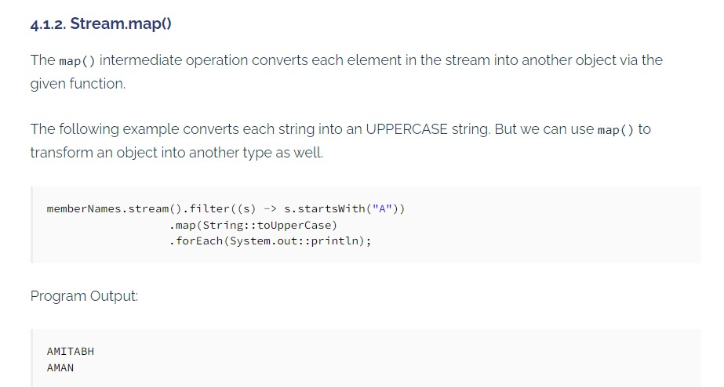

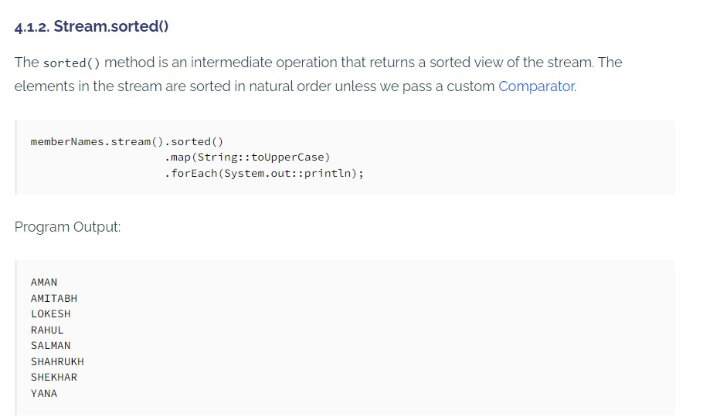

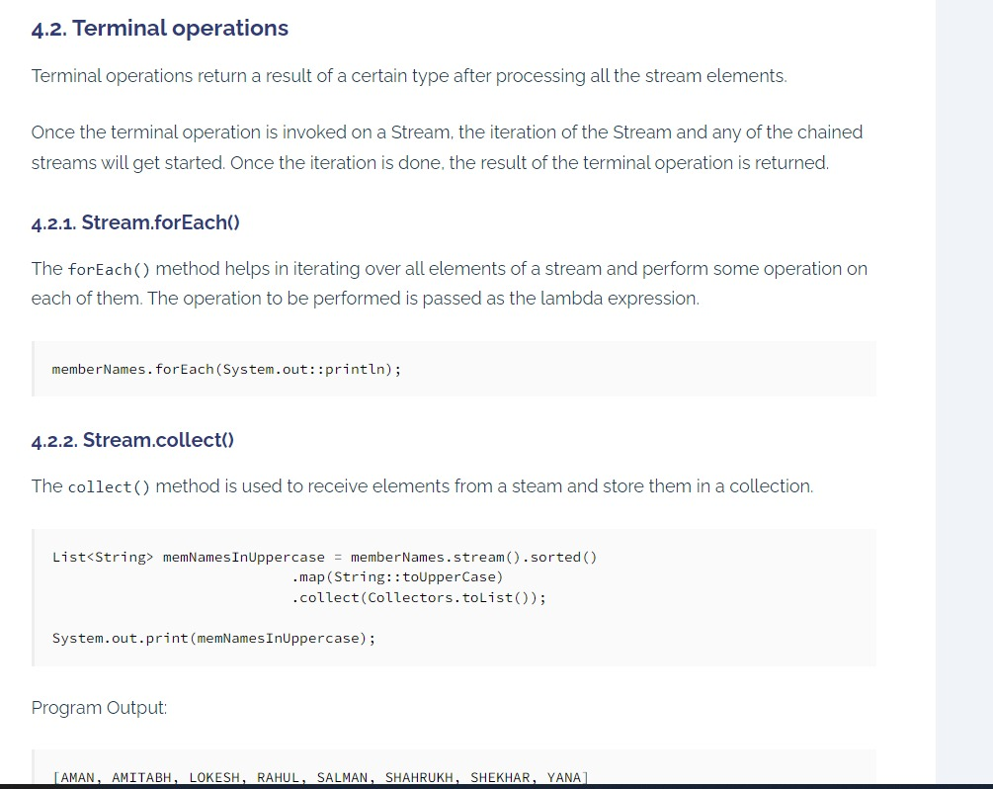

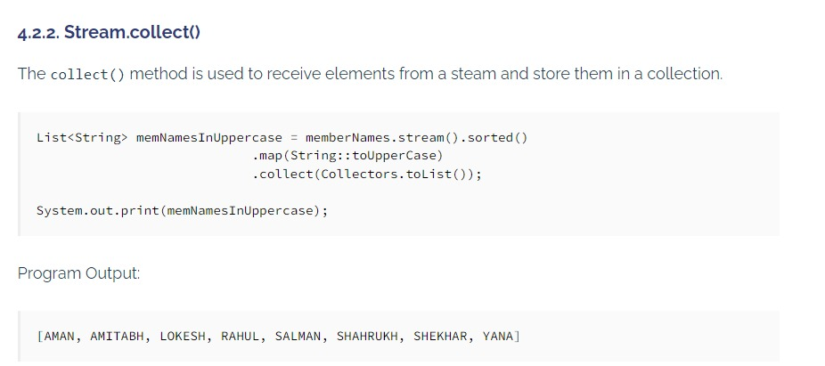

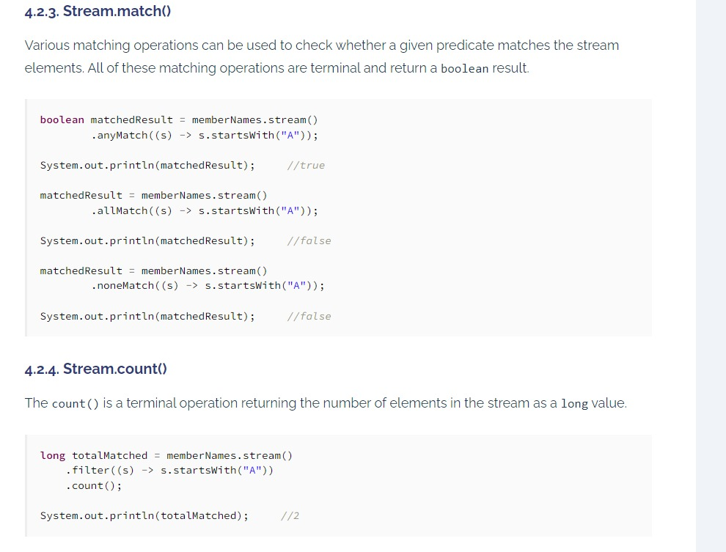

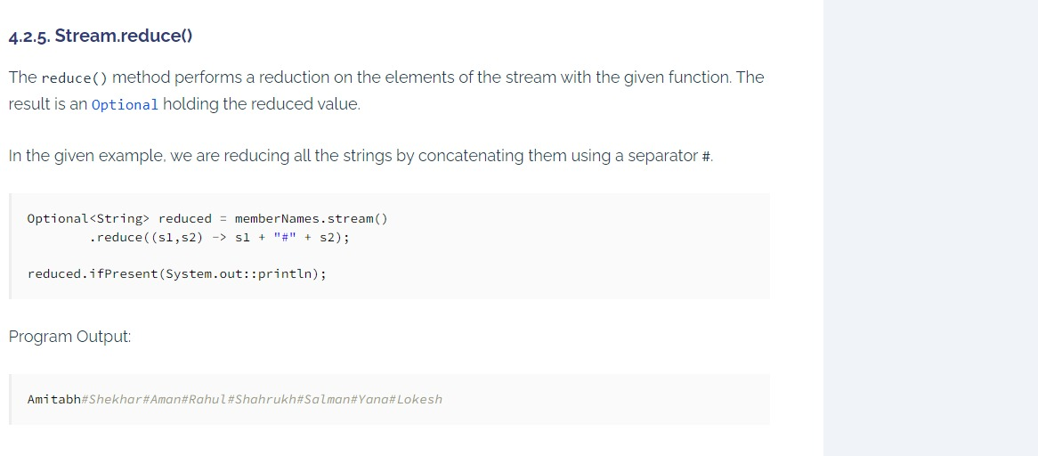

<https://howtodoinjava.com/java8/java-streams-by-examples/>

**ifPresent(Consumer<? super T> consumer)**

If a value is present, invoke the specified consumer with the value, otherwise do nothing.

**boolean isPresent()**

Return true if there is a value present, otherwise false.

**<U> Optional<U> map(Function<? super T,? extends U> mapper)**

If a value is present, apply the provided mapping function to it, and if the result is non-null, return an Optional describing the result.

**static <T> Optional<T> of(T value)**

Returns an Optional with the specified present non-null value.

**static <T> Optional<T> ofNullable(T value)**

Returns an Optional describing the specified value, if non-null, otherwise returns an empty Optional.

**T orElse(T other)**

Return the value if present, otherwise return other.

**T orElseGet(Supplier<? extends T> other)**

Return the value if present, otherwise invoke other and return the result of that invocation.

**<X extends Throwable>**

T orElseThrow(Supplier<? extends X> exceptionSupplier)

<https://docs.oracle.com/javase/8/docs/api/java/util/Date.html>

package com.demo.java8.optionalClasses;

import java.util.Optional;

import java.util.OptionalInt;

/*Java introduced a new class Optional in jdk8.

It is a public final class and used to deal with

NullPointerException in Java application.

You must import java.util package to use this class.

It provides methods which are used to check the presence of value for particular variable.*/

class OptionalClass {

public Integer Sum(Optional<Integer> a, Optional<Integer> b) {

System.out.println(a.isPresent());

System.out.println(b.isPresent());

// Optional.orElse - returns the value if present otherwise returns

// the default value passed.

Integer a1 = a.orElse(0);

// Optional.get - gets the value, value should be present

Integer b1 = b.get();

return a1+b1;

}

}

public class OptionalDemo {

public static void main(String ar[]) {

OptionalClass d = new OptionalClass();

Integer value1 = null; //passing null

Integer value2 = new Integer(10); //passing some values here like 10 45 78

Optional<Integer> a =Optional.ofNullable(value1); //checking null is passing is throwing exception or not

Optional<Integer> b =Optional.of(value2);

System.out.println(d.Sum(a, b));

}

}

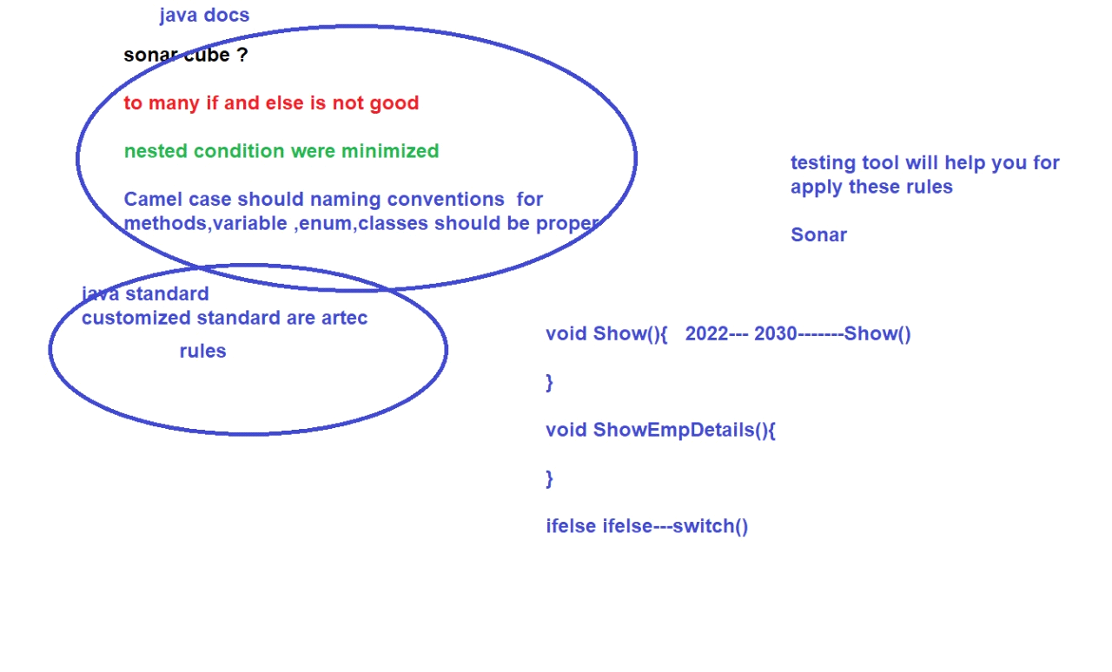

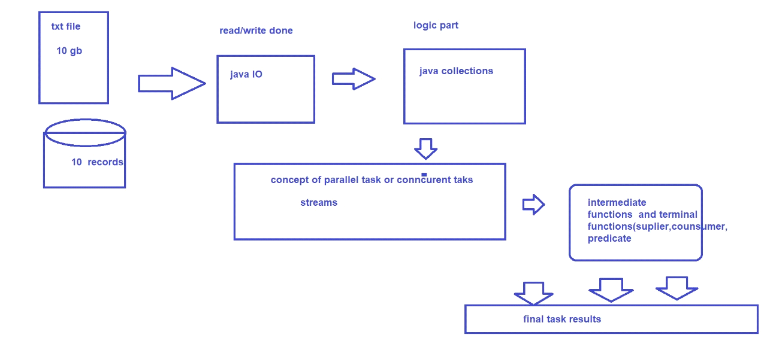

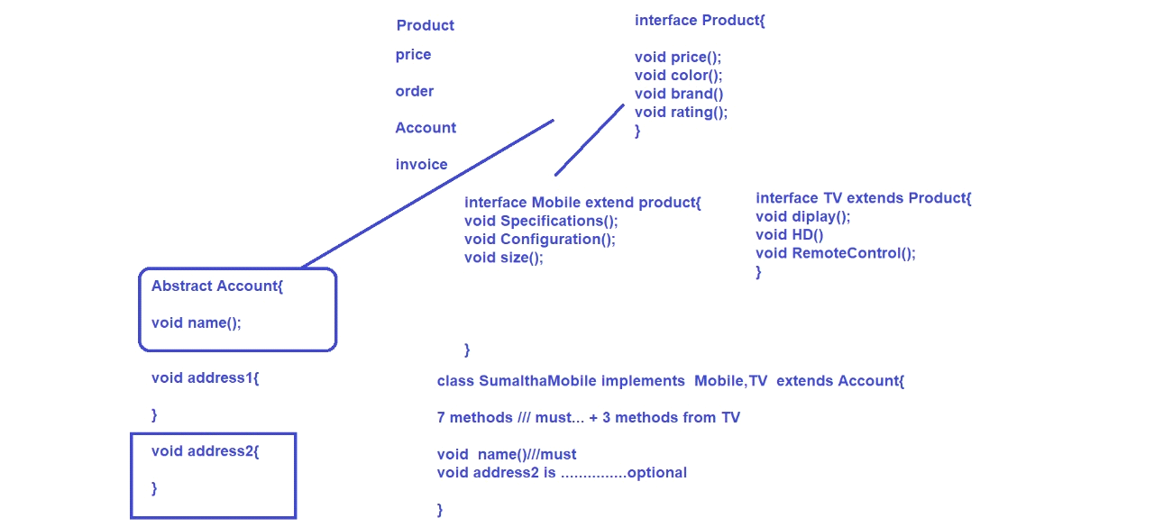

<https://www.geeksforgeeks.org/what-is-java-executor-framework/>

**Java concurrency - Thread pools**

<https://www.slideshare.net/maksym220889/java-concurrency-thread-pools>

**POSTGRES SQL**

<https://www.tutorialspoint.com/postgresql/postgresql_select_query.htm>

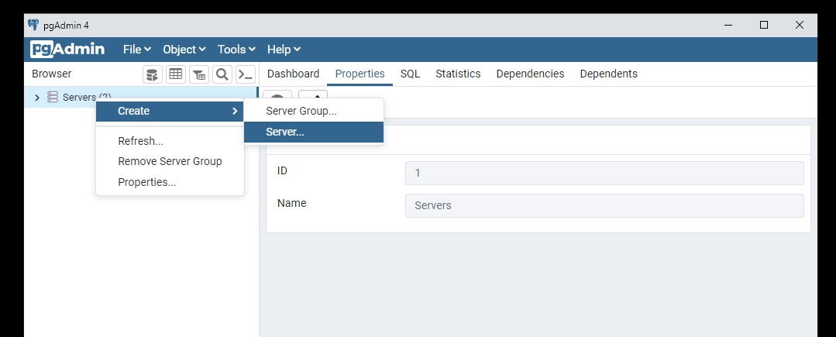

**Example program for sql:**

CREATE TABLE COMPANY(

ID INT PRIMARY KEY NOT NULL,

NAME TEXT NOT NULL,

AGE INT NOT NULL,

ADDRESS CHAR(50),

SALARY REAL

);

**SQL COMMANDS**

<https://www.postgresqltutorial.com/psql-commands/>

create db

select from connect db

create table

select from table

insert into table

update into table

delet from table

<https://www.slideshare.net/praveenjigajinni/11-database-concepts>

<https://www.geeksforgeeks.org/postgresql-data-types/>

<https://www.postgresql.org/docs/9.3/sql-createschema.html>

<https://www.tutorialspoint.com/postgresql/postgresql_schema.htm>

<https://www.slideshare.net/praveenjigajinni/11-database-concepts>

<https://www.w3schools.com/sql/sql_insert.asp>

-------------------------------------------------------------------------------------------------------------------

// A Java program to demonstrate that we should

// check if parameters are null or not before

// using them.

import java.io.*;

class GFG

{

public static void main (String[] args)

{

// String s set an empty string and calling getLength()

String s = "";

try

{

System.out.println(getLength(s));

}

catch(IllegalArgumentException e)

{

System.out.println("IllegalArgumentException caught");

}

// String s set to a value and calling getLength()

s = "GeeksforGeeks";

try

{

System.out.println(getLength(s));

}

catch(IllegalArgumentException e)

{

System.out.println("IllegalArgumentException caught");

}

// Setting s as null and calling getLength()

s = null;

try

{

System.out.println(getLength(s));

}

catch(IllegalArgumentException e)

{

System.out.println("IllegalArgumentException caught");

}

}

// Function to return length of string s. It throws

// IllegalArgumentException if s is null.

public static int getLength(String s)

{

if (s == null)

throw new IllegalArgumentException("The argument cannot be null");

return s.length();

}

}

________________________________________________________________________

Case 1.A: Example for checked exception:

This program has a method called calculate to do division

and it checks whether 2nd number is Zero

and accordingly raises/throws exception using throw keyword

ThrowKeywordForUncheckedException.java

?

1

2

3

4

5

6

7

8

9

10

11

12

13

14

15

16

17

18

19

package in.bench.resources.exception.handling;

public class ThrowKeywordForUncheckedException {

public static void main(String[] args) {

int result = calculate(19, 0);

System.out.println("Result of Division : "

+ result);

}

public static int calculate(int number1, int number2) {

if(number2 == 0) {

throw new ArithmeticException("divide by ZeeRoo");

}

return number1/number2;

}

}

Output:

?

1

2

3

4

5

6

7

8

Exception in thread "main" java.lang.ArithmeticException:

divide by ZeeRoo

at in.bench.resources.exception.handling

.ThrowKeywordForUncheckedException

.calculate(ThrowKeywordForUncheckedException.java:14)

at in.bench.resources.exception.handling

.ThrowKeywordForUncheckedException.

main(ThrowKeywordForUncheckedException.java:7)

-------------------------------------------------------------------------------------------------------------------

<https://www.benchresources.net/throw-keyword-in-java-exception-handling/>

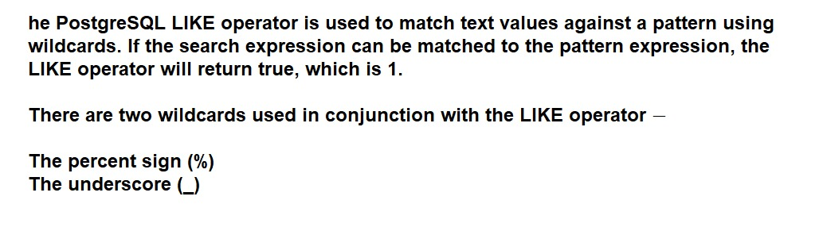

WHERE SALARY::text LIKE '200%'

Finds any values that start with 200

2

WHERE SALARY::text LIKE '%200%'

Finds any values that have 200 in any position

3

WHERE SALARY::text LIKE '_00%'

Finds any values that have 00 in the second and third positions

4

WHERE SALARY::text LIKE '2_%_%'

Finds any values that start with 2 and are at least 3 characters in length

5

WHERE SALARY::text LIKE '%2'

Finds any values that end with 2

6

WHERE SALARY::text LIKE '_2%3'

Finds any values that have 2 in the second position and end with a 3

7

WHERE SALARY::text LIKE '2___3'

Finds any values in a five-digit number that start with 2 and end with 3

<https://www.tutorialspoint.com/postgresql/postgresql_like_clause.htm>

select * from company where name LIKE 'ram%';

The PostgreSQL AND and OR operators

SELECT * FROM COMPANY WHERE AGE >= 25 AND SALARY >= 65000;

SELECT * FROM COMPANY WHERE AGE >= 25 OR SALARY >= 65000;

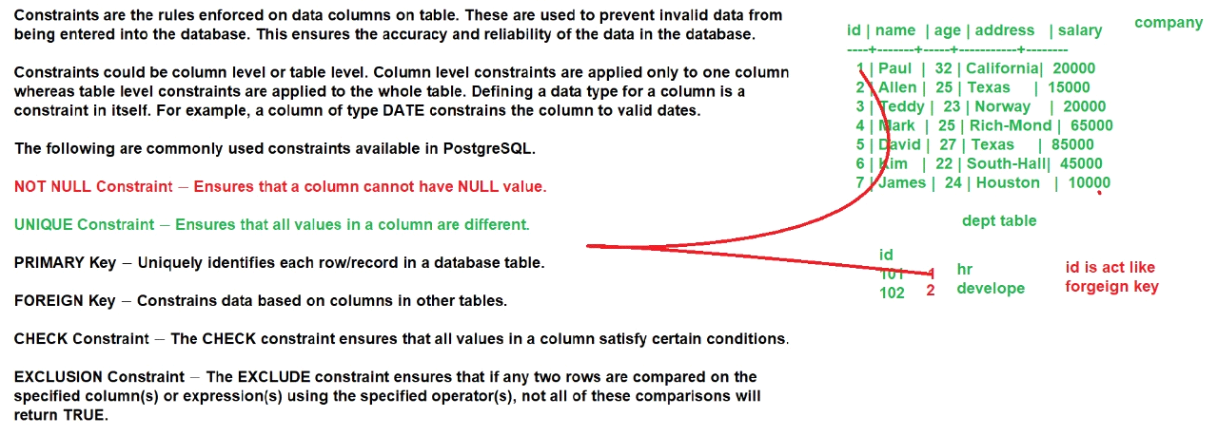

SELECT * FROM COMPANY ORDER BY AGE ASC;

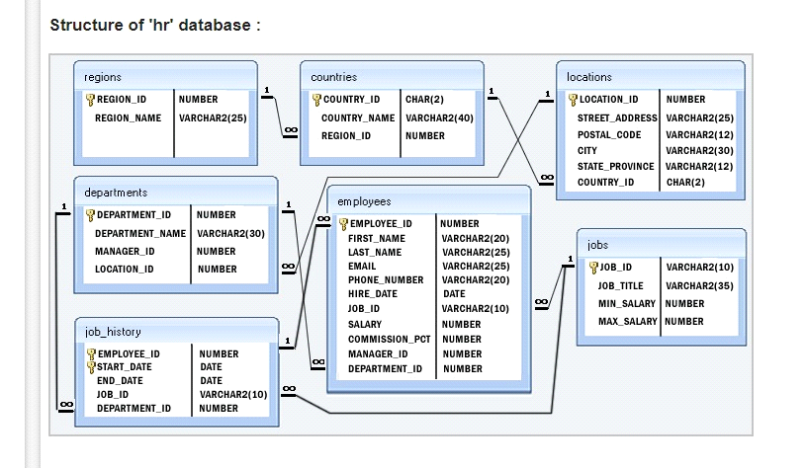

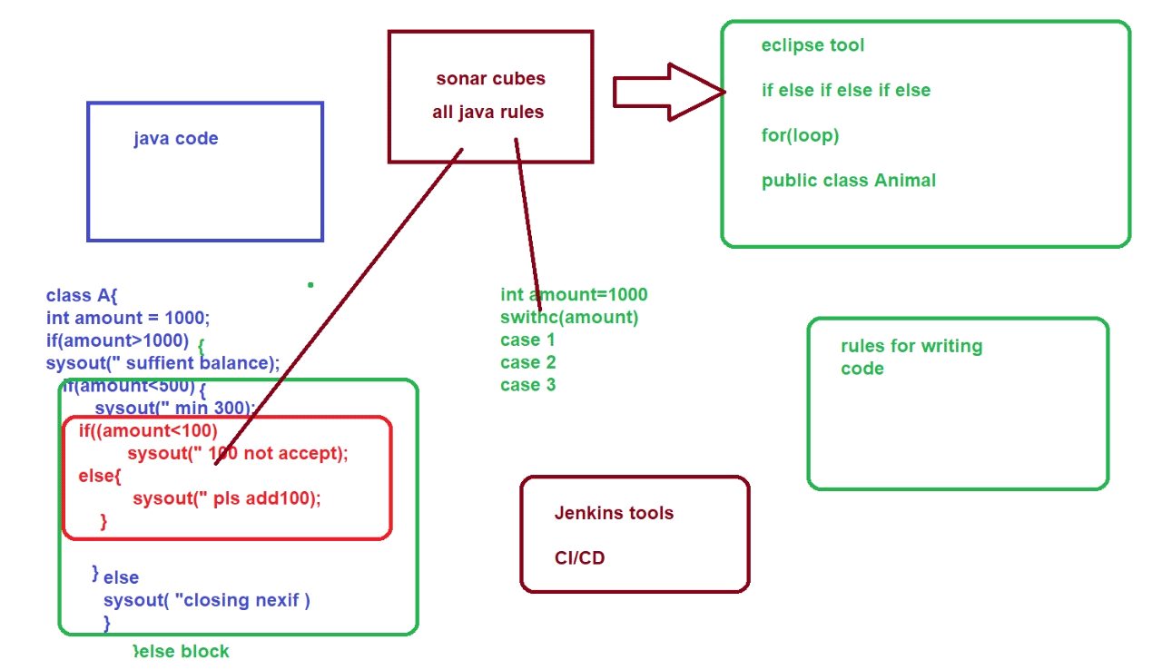

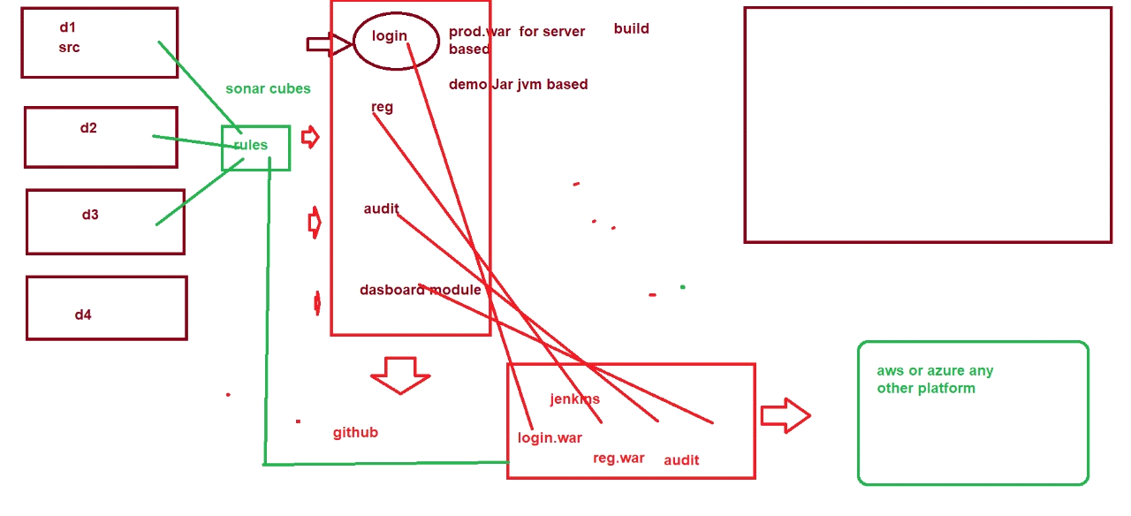

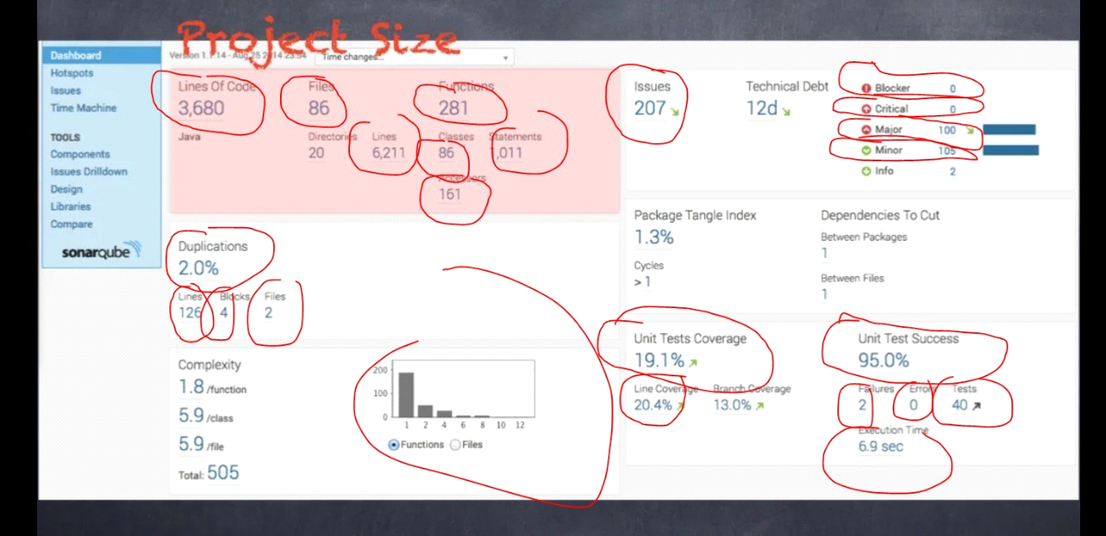

<https://www.slideshare.net/nuboat/sonar2>

<https://www.sonarqube.org/>

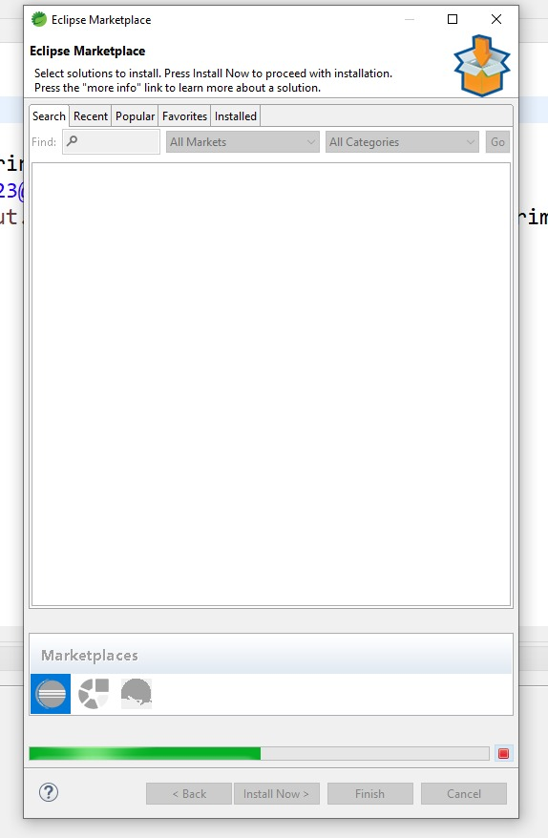

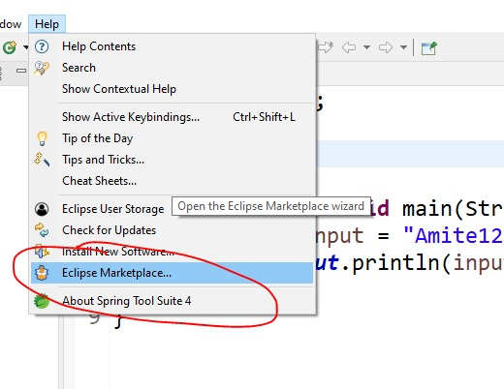

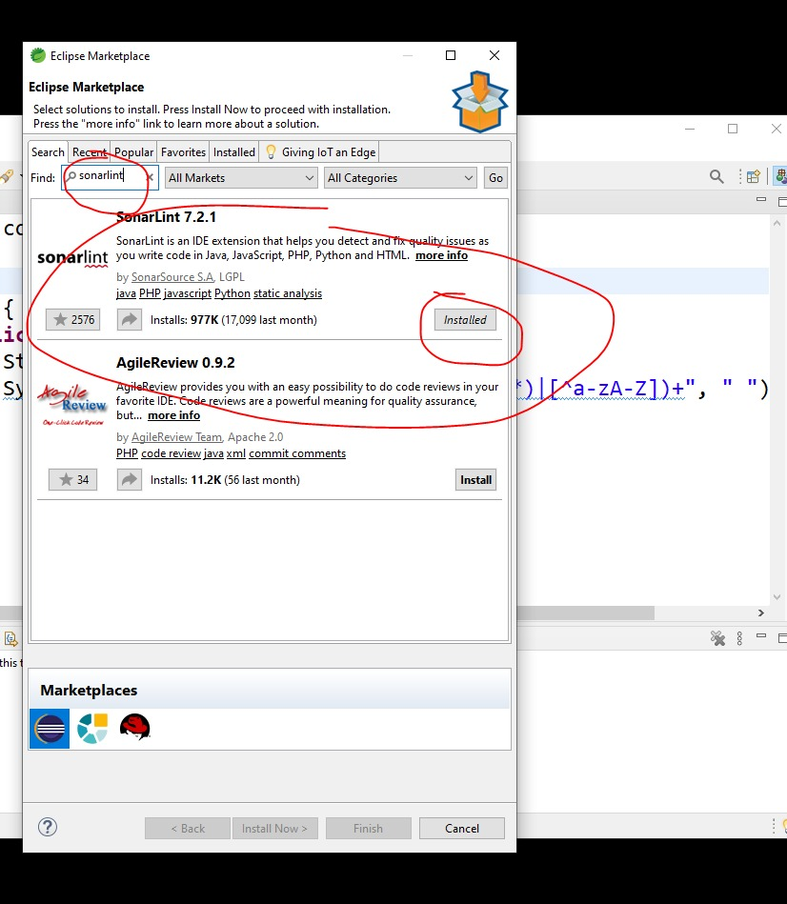

<https://www.sonarqube.org/success-download-community-edition/>

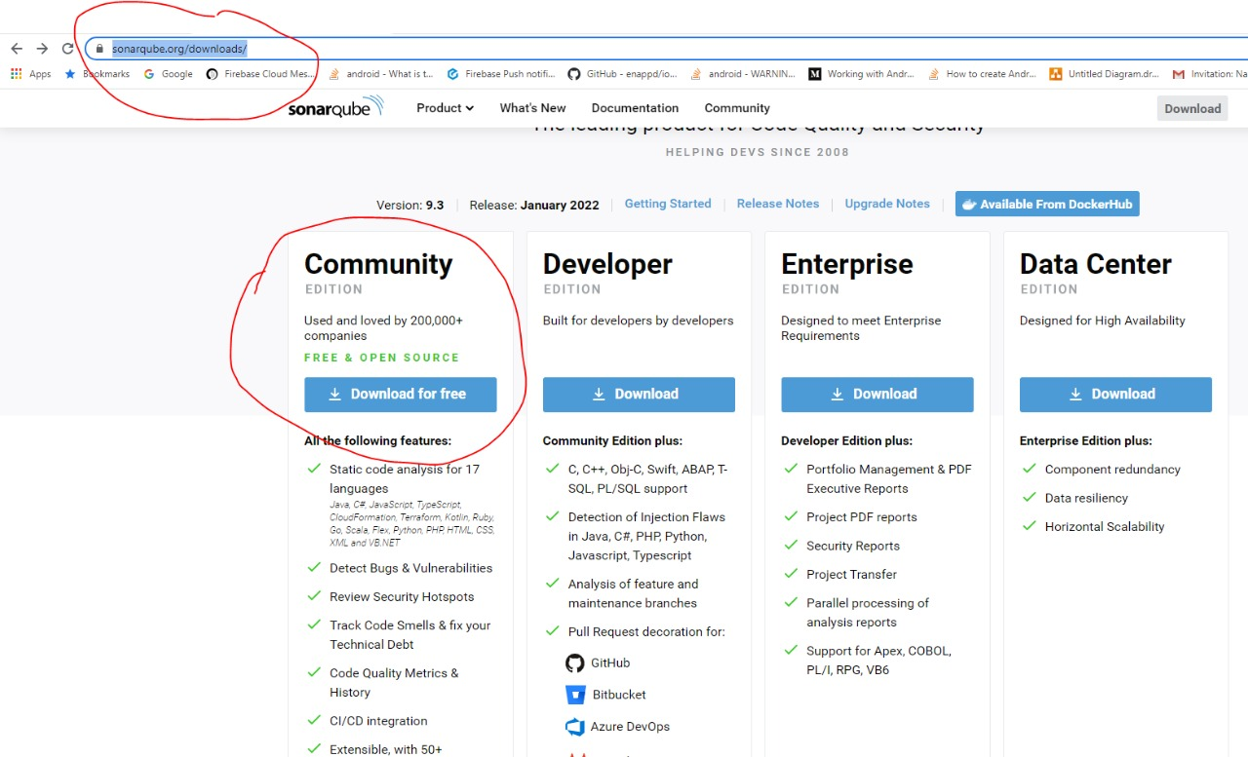

<https://gradle.org/>

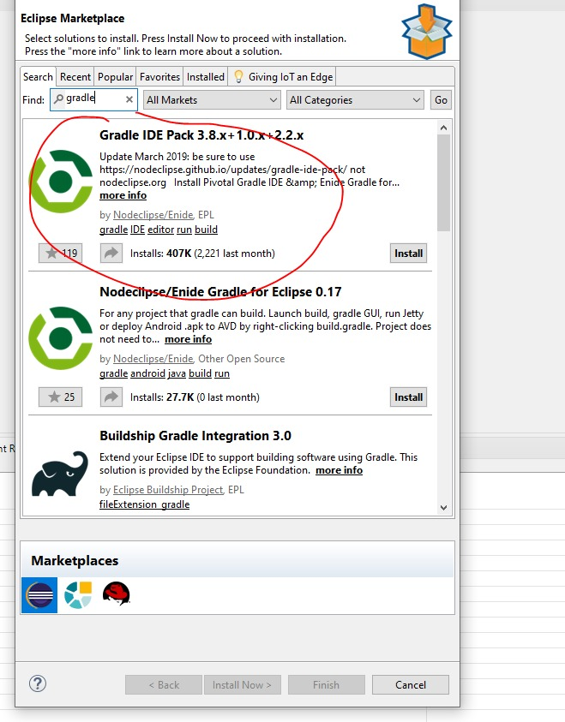

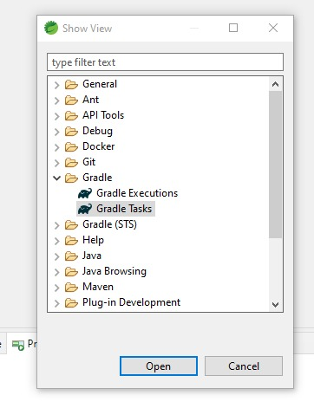

**JDBC**

<https://www.tutorialspoint.com/jdbc/index.htm>

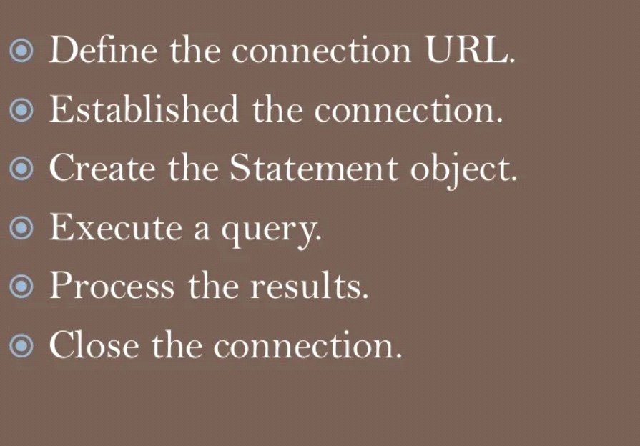

here are following six steps involved in building a JDBC application −

**Import the packages** − Requires that you include the packages containing the JDBC classes needed for database programming. Most often, using import java.sql.* will suffice.

**Open a connection** − Requires using the DriverManager.getConnection() method to create a Connection object, which represents a physical connection with the database.

**Execute a query** − Requires using an object of type Statement for building and submitting an SQL statement to the database.

**Extract data from result set** − Requires that you use the appropriate ResultSet.getXXX() method to retrieve the data from the result set.

**Clean up the environment** − Requires explicitly closing all database resources versus relying on the JVM's garbage collection.

<https://docs.oracle.com/cd/E19509-01/820-3497/agqka/index.html>

<https://mvnrepository.com/artifact/org.postgresql/postgresql/42.3.3>

<https://www.tutorialspoint.com/postgresql/postgresql_java.htm>

package com.demo;

import java.sql.Connection;

import java.sql.DriverManager;

import java.sql.SQLException;

public class Jdbc {

public static void main(String[] args) {

String username = "postgres";

String password = "root";

String url = "jdbc:postgresql://localhost:5432/dummy";

Connection con = null;// the

try {

System.out.println("loading driver connecting....");

Class.forName("org.postgresql.Driver");

con = DriverManager.getConnection( url,username, password);

System.out.println("connected...");

} catch (Exception e) {

System.out.println(e);

}

}

}

-------------------------------------------------------------------------------------------------------------------

import java.sql.Connection;

import java.sql.DriverManager;

import java.sql.ResultSet;

import java.sql.SQLException;

import java.sql.Statement;

public class Jdbc {

public static void main(String[] args) {

String username = "postgres";

String password = "root";

String url = "jdbc:postgresql://localhost:5432/dummy";

ResultSet rs =null;

Connection con = null;// the

try {

System.out.println("loading driver connecting....");

//driver name

Class.forName("org.postgresql.Driver");

//making connection

con = DriverManager.getConnection( url,username, password);

System.out..println("connected...");

Statement s = con.createStatement();

rs = s.executeQuery("select * from company");

while(rs.next()) {

int id =rs.getInt(1);

System.out.println(" id is"+id);

String names =rs.getString(2);

System.out.println(" names is"+names);

}

} catch (Exception e) {

System.out.println(e);

}

}

}

________________________________________________________________________

**Maven Dependencies:**

<project xmlns="http://maven.apache.org/POM/4.0.0"

xmlns:xsi="http://www.w3.org/2001/XMLSchema-instance"

xsi:schemaLocation="http://maven.apache.org/POM/4.0.0 <https://maven.apache.org/xsd/maven-4.0.0.xsd>">

<modelVersion>4.0.0</modelVersion>

<groupId>JDBC</groupId>

<artifactId>JDBC</artifactId>

<version>0.0.1-SNAPSHOT</version>

<name>jdbcdemo</name>

<dependencies>

<!-- <https://mvnrepository.com/artifact/org.postgresql/postgresql> -->

<dependency>

<groupId>org.postgresql</groupId>

<artifactId>postgresql</artifactId>

<version>42.3.3</version>

</dependency>

</dependencies>

<build>

<sourceDirectory>src</sourceDirectory>

<plugins>

<plugin>

<artifactId>maven-compiler-plugin</artifactId>

<version>3.8.1</version>

<configuration>

<source>1.8</source>

<target>1.8</target>

</configuration>

</plugin>

</plugins>

</build>

</project>

**HOW TO WRITE JDBC PROGRAM:**

1.Create a **Project**

2.Convert whole **project to maven**

#After converting it creates a file named **pom.xml**

3.Create **Package-> class**

**ASSIGNMENTS:**

How to create JDBC Connection?

What is Statement & ResultSet in JDBC?

How to execute and read select queries using JDBC?

How to update a record in the database using JDBC?

How to execute any type of query in JDBC?

What are the types of JDBC Statements available?

Write an example code for JDBC prepared statement.

Write an example for JDBC prepared statement with ResultSet.

How to get primary key value (auto-generated keys) from inserted queries using JDBC?

-------------------------------------------------------------------------------------------------------------------

<https://docs.oracle.com/javaee/7/api/javax/persistence/package-summary.html>

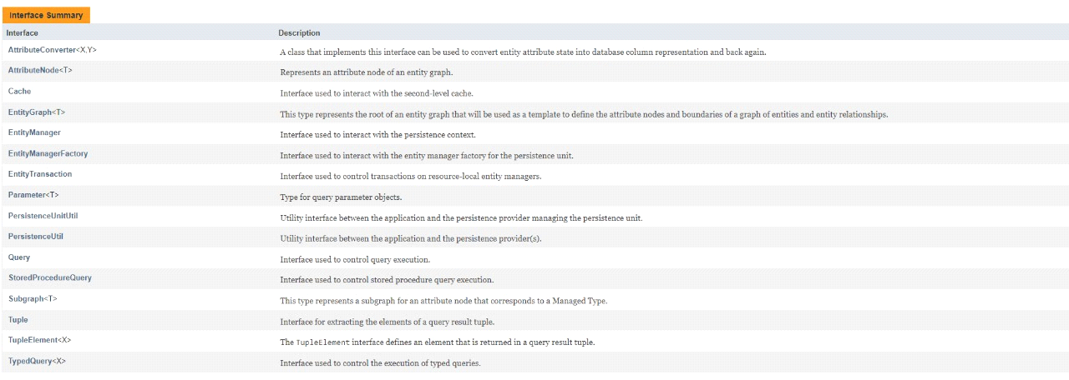

**JPA TYPES:**

**EnumType**

Defines mapping for enumerated types.

**FetchType**

Defines strategies for fetching data from the database.

**FlushModeType**

Flush mode setting.

**GenerationType**

Defines the types of primary key generation strategies.

**InheritanceType**

Defines inheritance strategy options.

**LockModeType**

Lock modes can be specified by means of passing a LockModeType argument to one of the EntityManager methods that take locks (lock, find, or refresh) or to the Query.setLockMode() or TypedQuery.setLockMode() method.

**ParameterMode**

Specifies the mode of a parameter of a stored procedure query.

**PersistenceContextType**

Specifies whether a transaction-scoped or extended persistence context is to be used in PersistenceContext.

**PessimisticLockScope**

Defines the values of the javax.persistence.lock.scope property for pessimistic locking.

**SharedCacheMode**

Specifies how the provider must use a second-level cache for the persistence unit.

**SynchronizationType**

Specifies whether the persistence context is always automatically synchronized with the current transaction or whether the persistence context must be explicitly joined to the current transaction by means of the EntityManager.joinTransaction() method.

**TemporalType**

Type used to indicate a specific mapping of java.util.Date or java.util.Calendar.

**ValidationMode**

The validation mode to be used by the provider for the persistence unit.

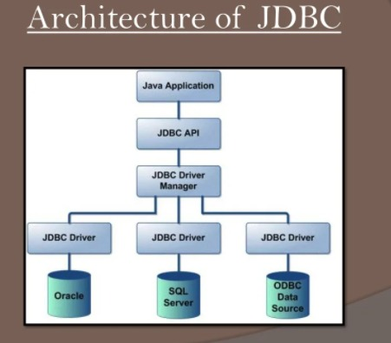

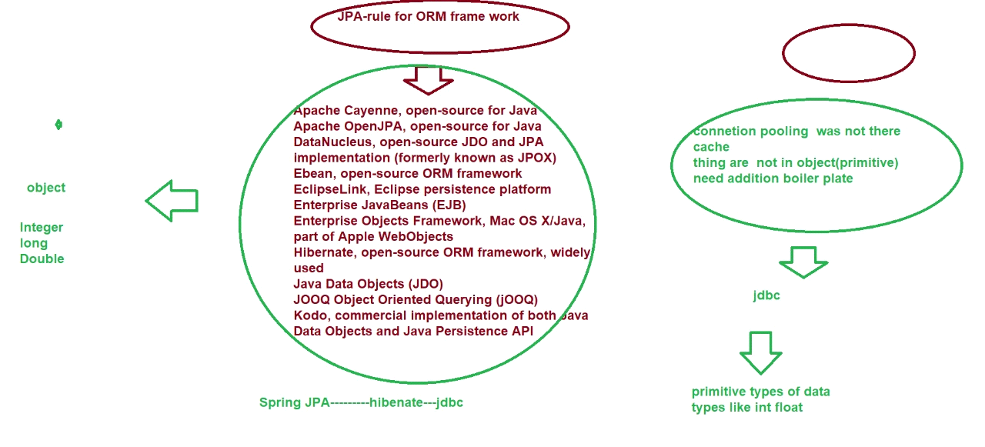

**HIBERNATE**

<https://docs.jboss.org/hibernate/orm/3.2/api/index.html>

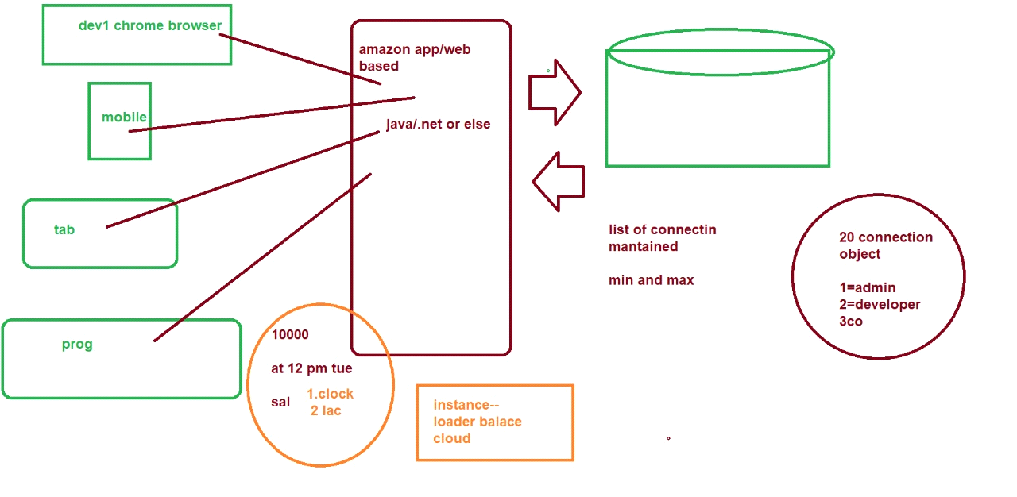

<https://www.tutorialspoint.com/hibernate/index.htm>

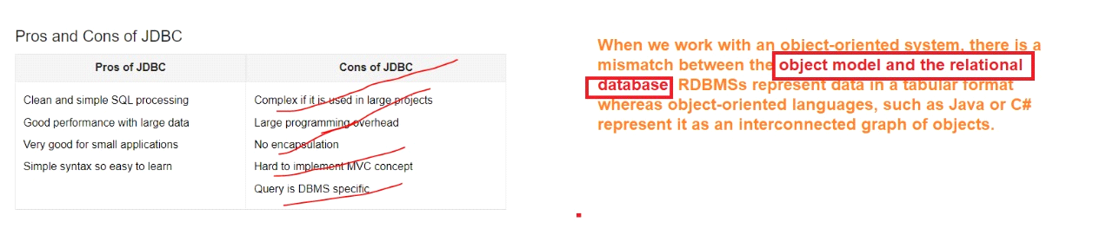

**HOW TO CREATE HIBERNATE:**

step 1 create java project

step 2 convert into maven project--for ease of donwloading dependencies

step 3 create java pojo class

step 4 create xml file for mapping database or using java annotation class

step5 create hibenate classmain

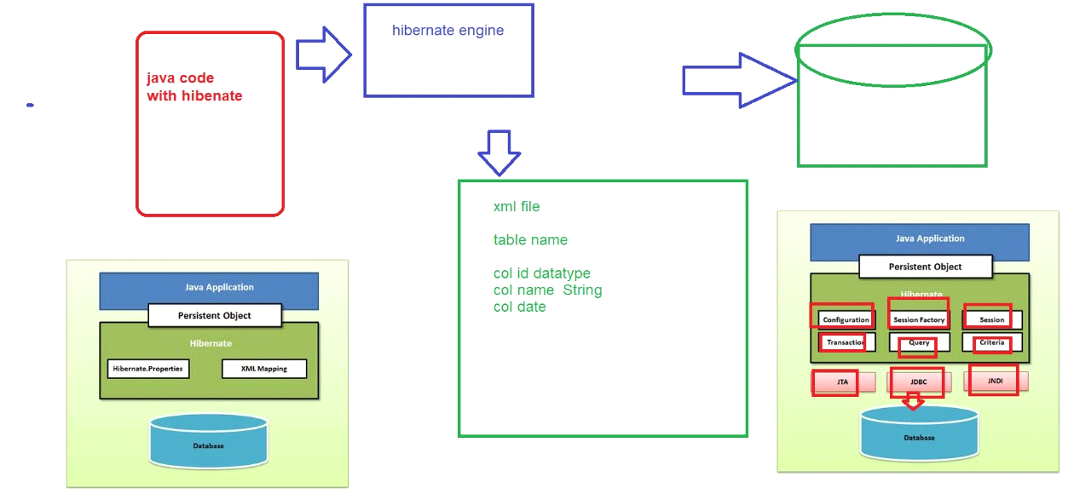

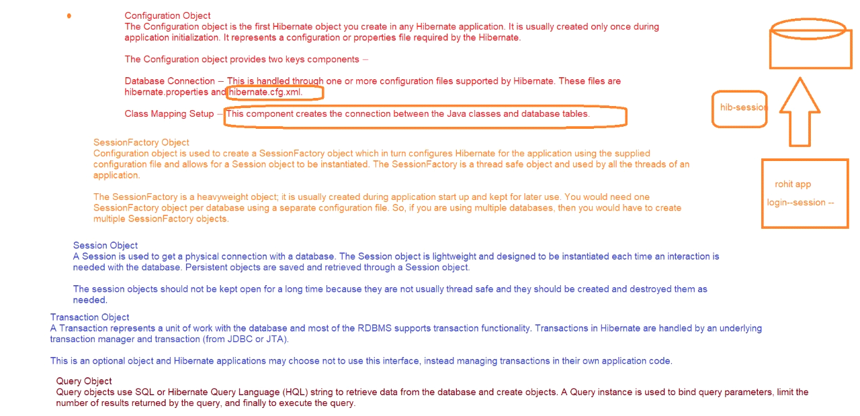

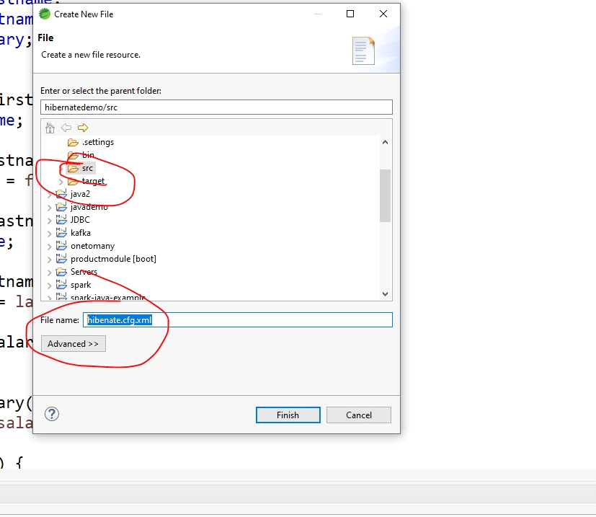

<https://www.onlinetutorialspoint.com/hibernate/generator-classes-in-hibernate.html>

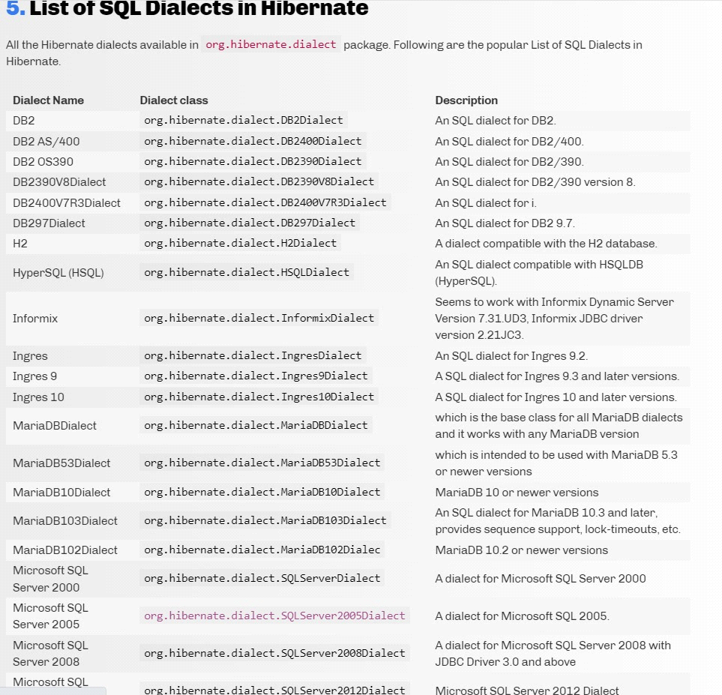

<https://www.tutorialspoint.com/hibernate/hibernate_mapping_types.htm>

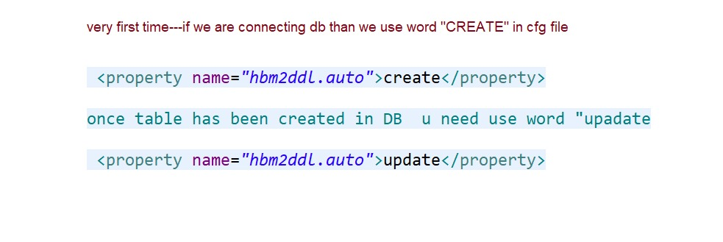

insert 1 or 0 for update 1 and or not update return 0

**OUTPUT:**

Hibernate: select nextval ('hibernate_sequence')

Hibernate: insert into employee (first_name, last_name, salary, id) values (?, ?, ?, ?)

result is3

Done....

dynamic creation of sql by hibernate engine

INFO: Checking 0 named queries

Hibernate: select employee0_.id as id, employee0_.first_name as first2_0_, employee0_.last_name as last3_0_, employee0_.salary as salary0_ from employee employee0_

first name isram

last name iskumar

salkumar

first name isram

last name iskumar

salkumar

Done....

for view values from db

<https://youtu.be/JR7-EdxDSf0>

**Steps to create hibernate:**

Step 1 Design schema

Step 2 Add Table structure

Step 3 create pojo or java bean

Step 4 create hbm.xml file for mapping the database

Step 5 if you are using Annotation than create POJO for mapping the database

Step 6 create session factory common class

Step 6 Add logic methods like add,update,delete,view or select

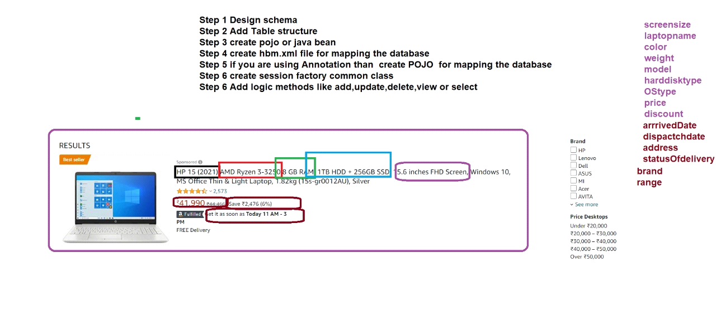

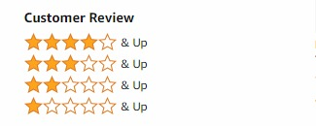

has a relation ship

public class Product {

private String screensize;

private String laptopname;

private String color;

private String weight;

private String model;

}

public class Rating {

private String numberOfStars;

private String rating;

}

**API'S**

public Product getProductDetailsById(long id); GET

public List<Product> getListOfAllProductdetails(); GET

public Product updateProductdetailsById(long id); PUT

public void deleteProductdetailsById(long id); delete

public void deleteAllProductDetails(); delete

public void addProductDetailsById(long id); POST

**UPDATED MAVEN DEPENDENCY**

<project xmlns="http://maven.apache.org/POM/4.0.0" xmlns:xsi="http://www.w3.org/2001/XMLSchema-instance" xsi:schemaLocation="http://maven.apache.org/POM/4.0.0 <https://maven.apache.org/xsd/maven-4.0.0.xsd>">

<modelVersion>4.0.0</modelVersion>

<groupId>com.demo</groupId>

<artifactId>hibernatedemo</artifactId>

<version>0.0.1-SNAPSHOT</version>

<properties>

<maven.compiler.plugin.version>3.5.1</maven.compiler.plugin.version>

<hibernate.version>5.1.0.Final</hibernate.version>

</properties>

<dependencies>

<!-- <https://mvnrepository.com/artifact/org.postgresql/postgresql> -->

<dependency>

<groupId>org.postgresql</groupId>

<artifactId>postgresql</artifactId>

<version>42.3.3</version>

</dependency>

<dependency>

<groupId>org.hibernate</groupId>

<artifactId>hibernate-core</artifactId>

<version>${hibernate.version}</version>

</dependency>

<!-- <https://mvnrepository.com/artifact/dom4j/dom4j> -->

<dependency>

<groupId>dom4j</groupId>

<artifactId>dom4j</artifactId>

<version>1.6.1</version>

</dependency>

<!-- <https://mvnrepository.com/artifact/commons-collections/commons-collections> -->

<dependency>

<groupId>commons-collections</groupId>

<artifactId>commons-collections</artifactId>

<version>3.1</version>

</dependency>

<!-- <https://mvnrepository.com/artifact/commons-logging/commons-logging> -->

<dependency>

<groupId>commons-logging</groupId>

<artifactId>commons-logging</artifactId>

<version>1.2</version>

</dependency>

<!-- <https://mvnrepository.com/artifact/net.sf.ehcache/ehcache> -->

<dependency>

<groupId>net.sf.ehcache</groupId>

<artifactId>ehcache</artifactId>

<version>2.10.4</version>

</dependency>

<!-- <https://mvnrepository.com/artifact/cglib/cglib> -->

<dependency>

<groupId>cglib</groupId>

<artifactId>cglib</artifactId>

<version>2.2.2</version>

</dependency>

<dependency>

<groupId>javax.transaction</groupId>

<artifactId>jta</artifactId>

<version>1.1</version>

</dependency>

<dependency>

<groupId>antlr</groupId>

<artifactId>antlr</artifactId>

<version>2.7.7</version>

</dependency>

<dependency>

<groupId>org.slf4j</groupId>

<artifactId>slf4j-api</artifactId>

<version>1.7.27</version>

</dependency>

<!-- Thanks for using [https://jar-download.com](https://jar-download.com/) -->

</dependencies>

<build>

<sourceDirectory>src</sourceDirectory>

<plugins>

<plugin>

<artifactId>maven-compiler-plugin</artifactId>

<version>3.8.1</version>

<configuration>

<source>1.8</source>

<target>1.8</target>

</configuration>

</plugin>

</plugins>

</build>

</project>

**Example:**

**Logic Part**

List<Employee> getEmplist(){

sessionFactory = new Configuration().configure().buildSessionFactory();

sessiong = sessionFactory.openSession();

Query query = sessiong.createQuery("FROM Employee");

List<Employee> employeelist = query.list();

return employeelist;

}

**(main class)**

//list of employee

List<Employee> employeelist = crudOperation.getEmplist();

for (Employee newlist : employeelist) {

System.out.println("first name is" + newlist.getFirstname());

System.out.println("last name is" + newlist.getLastname());

System.out.println("sal" + newlist.getSalary());

}

**Logic part**

String deleteAllEmployeRecord() {

sessionFactory = new Configuration().configure().buildSessionFactory();

sessiong = sessionFactory.openSession();

transcation = sessiong.beginTransaction();

Query query = sessiong.createQuery("DELETE FROM Employee");

Integer result = query.executeUpdate();

transcation.commit();

if (result > 0) {

return "Sucessfully deleted all records";

} else {

return "No record found";

}

}

**Main Class**

String result =crudOperation.deleteAllEmployeRecord();

System.out.println(result);

**ANNOTATIONS:**

[**https://www.tutorialspoint.com/hibernate/hibernate_annotations.htm**](https://www.tutorialspoint.com/hibernate/hibernate_annotations.htm)

**Code for pojo class of Annotation:**

import javax.persistence.*;

@Entity

@Table(name = "EMPLOYEE")

public class Employee {

@Id @GeneratedValue

@Column(name = "id")

private int id;

@Column(name = "first_name")

private String firstName;

@Column(name = "last_name")

private String lastName;

@Column(name = "salary")

private int salary;

public Employee() {}

public int getId() {

return id;

}

public void setId( int id ) {

this.id = id;

}

public String getFirstName() {

return firstName;

}

public void setFirstName( String first_name ) {

this.firstName = first_name;

}

public String getLastName() {

return lastName;

}

public void setLastName( String last_name ) {

this.lastName = last_name;

}

public int getSalary() {

return salary;

}

public void setSalary( int salary ) {

this.salary = salary;

}

}

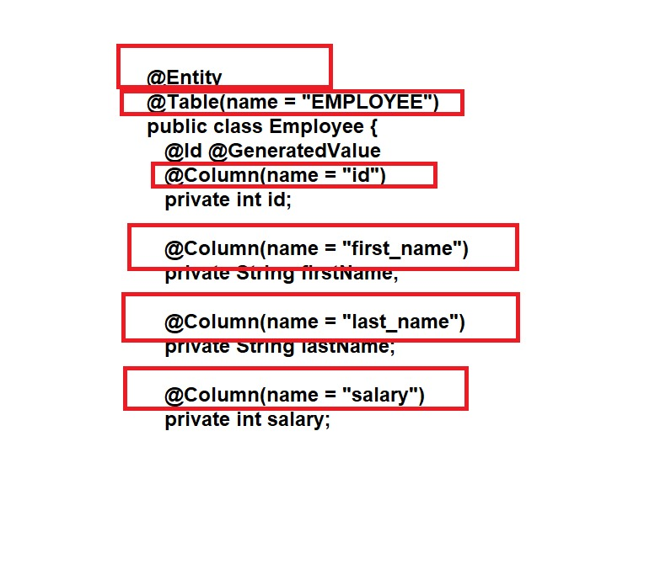

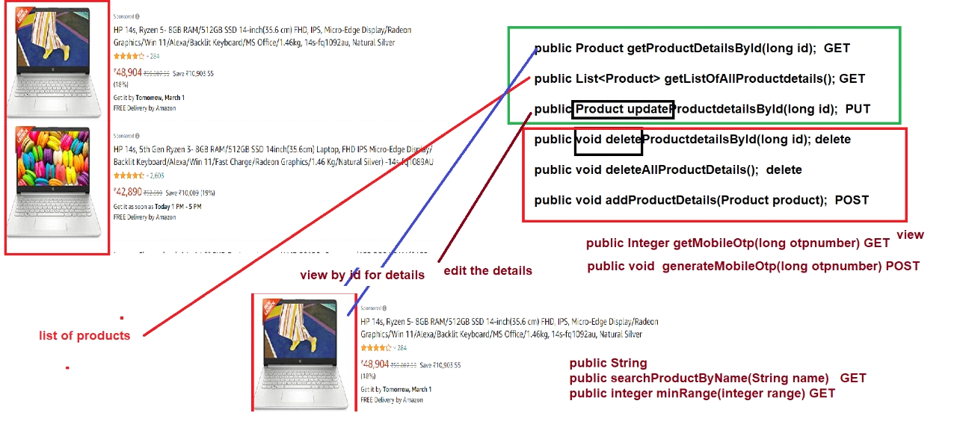

<mapping class="com.demo.pojo"/>

<https://www.postgresql.org/docs/9.2/datatype-numeric.html#DATATYPE-SERIAL>

<https://stackoverflow.com/questions/60621703/why-primary-key-ids-are-not-in-sequence>

**MAPPING ANNOTATION**

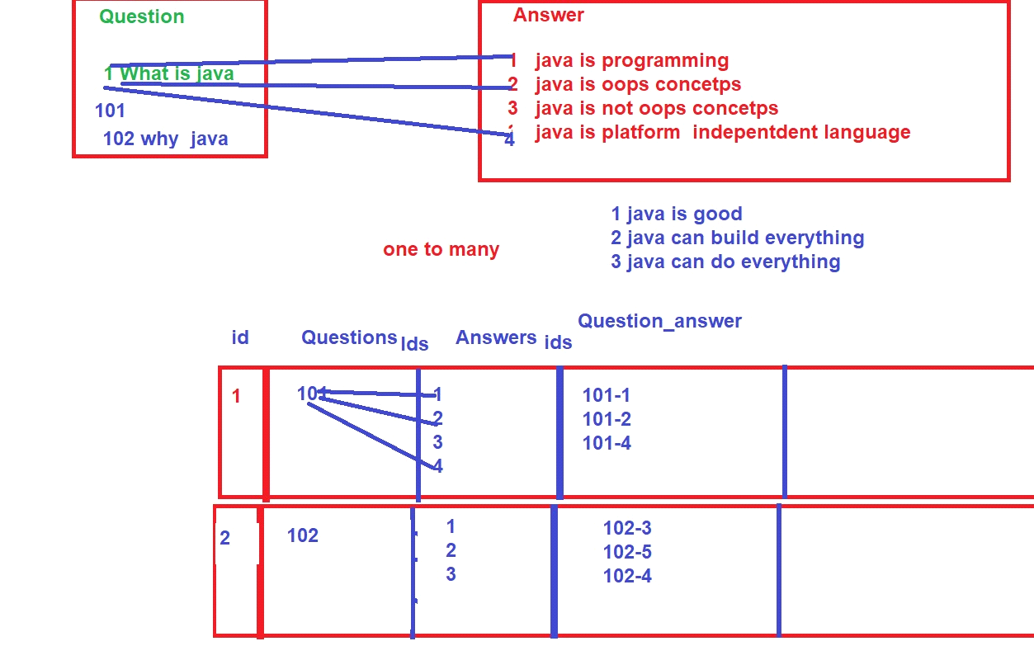

<https://www.javatpoint.com/hibernate-one-to-many-mapping-using-annotation-example>